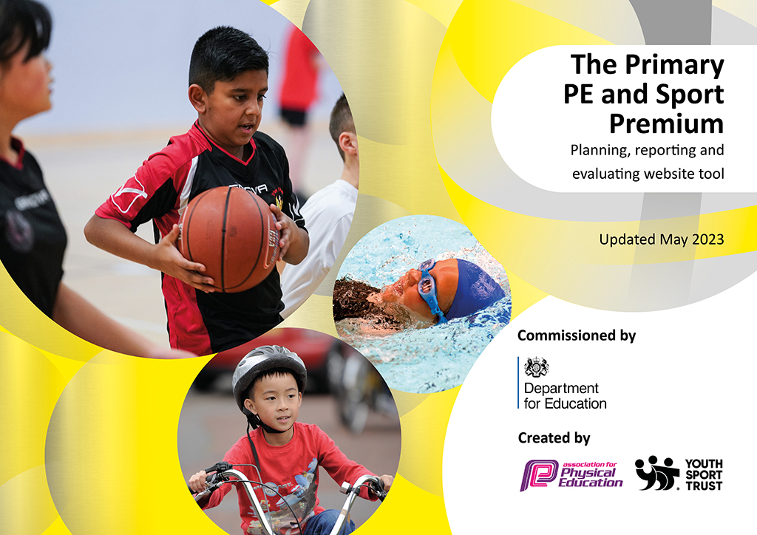
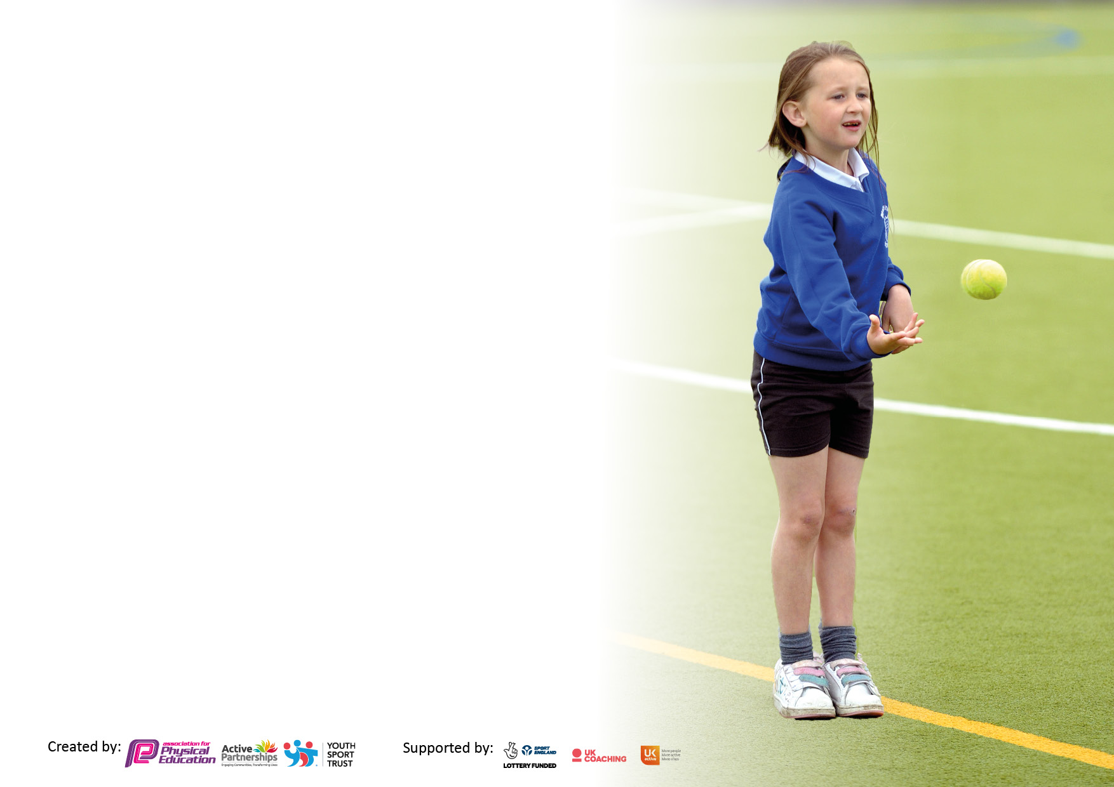

It is important that your grant is used effectively and based on school need. The Education Inspection Framework makes clear there will be a focus on ‘whether leaders and those responsible for governors all understand their respective roles and perform these in a way that enhances the effectiveness of the school’.

Under the Quality of Education Ofsted inspectors consider:
Intent - Curriculum design, coverage and appropriateness
Implementation - Curriculum delivery, Teaching (pedagogy) and Assessment
Impact - Attainment and progress

To assist schools with common transferable language this template has been developed to utilise the same three headings which should make your plans easily transferable between working documents.

Schools must use the funding to make additional and sustainable improvements to the quality of Physical Education, School Sport and Physical Activity (PESSPA) they offer. This means that you should use the Primary PE and sport premium to:

- Develop or add to the PESSPA activities that your school already offer
- Build capacity and capability within the school to ensure that improvements made now will benefit pupils joining the school in future years
- The Primary PE and sport premium should not be used to fund capital spend projects; the school’s budget should fund these.

Pleasevisitgov.ukfortherevisedDfEguidanceincludingthe5keyindicatorsacrosswhichschoolsshoulddemonstrate animprovement.Thisdocumentwillhelpyoutoreviewyourprovisionandtoreportyourspend.DfEencouragesschools to use this template as an effective way of meeting the reporting requirements of the Primary PE and Sport Premium.

We recommend you start by reflecting on the impact of current provision and reviewing the previous spend.

Schools are required to publish details of how they spend this funding, including any under-spend from 2021/2022, as well as on the impact it has on pupils’ PE and sport participation and attainment. All funding must be spent by 31st July 2023.

We recommend regularly updating the table and publishing it on your website throughout the year. This evidences your ongoing self-evaluation of how you are using the funding to secure maximum, sustainable impact. Final copy must be posted on your website by the end of the academic year and no later than the 31st July 2023. To see an example of how to complete the table please click HERE.

Details with regard to funding
Please complete the table below.

Total amount carried over from 2021/22 | £0
Total amount allocated for 2021/22 | £0
How much (if any) do you intend to carry over from this total fund into 2022/23? | £0
Total amount allocated for 2022/23 | £0
Total amount of funding for 2023/24. To be spent and reported on by 31st July 2023. | £18,710
Swimming Data
Please report on your Swimming Data below.

Meeting national curriculum requirements for swimming and water safety.

N.B. Complete this section to your best ability. For example you might have practised safe self-rescue techniques on dry land which you can then transfer to the pool when school swimming restarts.
Due to exceptional circumstances priority should be given to ensuring that pupils can perform safe self rescue even if they do not fully meet the first two requirements of the NC programme of study
What percentage of your current Year 6 cohort swim competently, confidently and proficiently over a distance of at least 25 metres?  N.B. Even though your pupils may swim in another year please report on their attainment on leaving primary school at the end of the summer term 2022.  Please see note above | 60%
What percentage of your current Year 6 cohort use a range of strokes effectively [for example, front crawl, backstroke and breaststroke]?  Please see note above | 60%
What percentage of your current Year 6 cohort perform safe self-rescue in different water-based situations? | 100%
Schools can choose to use the Primary PE and sport premium to provide additional provision for swimming but this must be for activity over and above the national curriculum requirements. Have you used it in this way? | No

Action Plan and Budget Tracking
Capture your intended annual spend against the 5 key indicators. Clarify the success criteria and evidence of impact that you intend to measure to evaluate for pupils today and for the future.

Academic Year: 2022/23 | Total fund allocated: £18,502 | Date Updated: July 2023
Key indicator 1: The engagement of all pupils in regular physical activity – Chief Medical Officers guidelines recommend that primary school pupils undertake at least 30 minutes of physical activity a day in school |  |  |  | Percentage of total allocation:
 |  |  |  | 48%
Intent | Implementation |  | Impact
Your school focus should be clear what you want the pupils to know and be able to do and about  what they need to learn and to  consolidate through practice: | Make sure your actions to achieve are linked to your intentions: | Funding allocated: | Evidence of impact: what do pupils now know and what can they now do? What has changed?: | Sustainability and suggested next steps:
For pupils to use the equipment/ resources provided on the playground/ play areas at break times (1 hour in total).  To provide a broad and balanced programme of physical education to ensure that every child should have activities designed to be enjoyable, purposeful and regular (PE passport).  In CLASP sessions for KS1 and KS2 offer additional access to sports and physical activity.  To provide a specialist dance teacher to provide after school clubs for children.  To give weekly certificates out in achievement assemblies focusing on participation in lessons to celebrate all children’s successes.  To ensure pupil have mindfulness brain breaks.  Y3 children attend swimming lessons so they can achieve the 3 aims. | Each playground has a variety of physical games, children can engage with these each playtime with a midday assistant modeling how to play it.  We have used PE passport to ensure that child access challenging and purposeful lessons, which are closely monitored through lesson observations and drop ins.  We offer a range of extra curricular activities such as; golf, dance and boxing.  We have playtime leaders to ensure children engage in purposeful play.  We have Bewsey Bee’s on the playground, responsible for encouraging children to join in with games.  We have subject champion meetings where the children update the P.E. lead on new equipment needed. | £8919 | Pupils are move active during playtimes and engage in purposeful activities.  Children have been exposed to wider range of skills. When carrying out a pupils voice survey children could name these skills and articulate on them.  Attitudes to learning have improved with better concentration and engagement as activities are inspiring and engaging.  Inspired to pursue different sports and physical activity.  Enjoyment of physical activity increased.  Children using skills/games from PE lessons and independently playing them on the playground.  Monitoring systems will provide clear, valid and reliable data to improve future targeting of our least active.  Children should be able to; competently, confidently and proficiently over a distance of at least 25 metres, | Equipment is permanent on playgrounds.  Resources can be replaced with fundraising from the school council/P.E funding.  Continue to develop CPD for all staff.  The monitoring system in place is sustainable and will be continually used beyond the academic year.
Key indicator 2: The profile of PESSPA being raised across the school as a tool for whole school improvement |  |  |  | Percentage of total allocation:
 |  |  |  | 5%
Intent | Implementation |  | Impact
Your school focus should be clear what you want the pupils to know and be able to do and about  what they need to learn and to  consolidate through practice: | Make sure your actions to achieve are linked to your intentions: | Funding allocated: | Evidence of impact: what do pupils now know and what can they now do? What has changed?: | Sustainability and suggested next steps:
PE champions to be chosen and are active members of decision making throughout the school year.  Children participating in sports day, in-house competitions, football tournaments, and rugby tournaments.  Provide PE kits for children whom don’t have one so they can participate in lessons. | Meet with PE champions regularly to discuss fundraising opportunities and competitions.  Order and purchase sports day rewards, certificates and medals for other whole school competitions.  Half termly assessments on PE passport to ensure accurate assessments are completed to identify areas of development for children. | £950 | PE champions support in organising a whole school dodge ball competitions, take part in football/rugby competitions.  All children participated in a sports day.  Children are able exposed to events in the wider community and develop their skill set.  Children can participate in PE in appropriate clothing to maximise performance, use a range of strokes effectively and safe self-rescue | Continue to invest in PE Passport to ensure children are provided with an enriched curriculum with a continued aim to raise attainment.  Continue to organise whole school competitions.  Continue to involve PE champions in the wider organisation of school competitions.

Key indicator 3: Increased confidence, knowledge and skills of all staff in teaching PE and sport |  |  |  | Percentage of total allocation:
 |  |  |  | 3%
Intent | Implementation |  | Impact
Your school focus should be clear | Make sure your actions to | Funding | Evidence of impact: what do | Sustainability and suggested
what you want the pupils to know | achieve are linked to your | allocated: | pupils now know and what | next steps:
and be able to do and about | intentions: |  | can they now do? What has
what they need to learn and to |  |  | changed?:
consolidate through practice:
To provide staff with professional development, training and resources to help further develop their knowledge of delivering outstanding PE lessons.  To carry out observations of PE lessons to provide support and guidance to PE teaching staff.  To employ a specialist dance teacher who can continue to develop children’s skills.  To employ Warrington Wolves Foundation to deliver specialist lessons for our DP provision. | Observe PE sessions.  Organise an outside trained PE coach to come and observe.  CPD training provided PE teaching staff along with mental wellbeing training.  Monitoring of PE Passport.  Analysing and reporting DATA to Governors.  Dance coach to deliver weekly/termly sessions and workshops.  Specialist PE coach to deliver weekly sessions in the DP. | £599 | PE coach observed by trained PE specialist, whom feedback indicated that his skill set and knowledge was strong (observation records evidence this).  Pupil voice questionnaire to evaluate children’s understanding of skills/understanding of delivery of teaching.  Teachers have a greater understanding of National Curriculum.  PE lead continued to monitor EYFS planning and delivery to ensure a smooth transition from EYFS to KS1. | Most pupils enjoy PE (pupil voice questionnaire)  PE teaching is of a good standard.  PE coach is confident to deliver a variety of skills and can use a range of vocabulary.
Key indicator 4: Broader experience of a range of sports and activities offered to all pupils |  |  |  | Percentage of total allocation:
 |  |  |  | 32%
Intent | Implementation |  | Impact
Your school focus should be clear | Make sure your actions to | Funding | Evidence of impact: what do | Sustainability and suggested
what you want the pupils to know | achieve are linked to your | allocated: | pupils now know and what | next steps:
and be able to do and about | intentions: |  | can they now do? What has
what they need to learn and to |  |  | changed?:
consolidate through practice:
For Warrington Wolves specialist coaches to continue to teach our designated provisions a broad range of sports and activities.  For children to take part in fitbox, golf and fnace that will be delivered by a specialist coach at their facility.  For some children to take part in golf lessons at a local golf club.  For children to have access to dance lessons and participate in shows to display their skills. | Contact Warrington Wolves to book every Wednesday afternoon for SEND children.  Organise swimming lessons.  Book Fitbox instructor and organise transport.  Book golf coach and transport.  Book boxing coach and transport.  Book specialist dance coach. | £5890 | Our sports coach and T.A’s can work alongside the Warrington Wolves coaches to build confidence in challenging and supporting the pupils in Designated Provision, in P.E. sessions. This is then used to support these pupils during break times outside too.  24 children participated in golf.  24 children participated in Boxing.  KS1 and KS2 children performed at a summer show. | Continue to make links with the schools we have established links with this year.  Continue to invest in children attending extra curricular activities, beyond the curriculum.  Continue to arrange shows with dance teacher so children have the opportunity to perform as much as possible.

Key indicator 5: Increased participation in competitive sport |  |  |  | Percentage of total allocation:
 |  |  |  | 19%
Intent | Implementation |  | Impact
Your school focus should be clear | Make sure your actions to | Funding | Evidence of impact: what do | Sustainability and suggested
what you want the pupils to know | achieve are linked to your | allocated: | pupils now know and what | next steps:
and be able to do and about | intentions: |  | can they now do? What has
what they need to learn and to |  |  | changed?:
consolidate through practice:
For P.E. coaches to deliver afterschool clubs that can lead to competitions.  To organise whole schoolhouse competitions.  For children to attend golf and participate in competitions. | Identify staff members to run after school sports clubs.  Organise whole schoolhouse competitions with subject champions.  Arrange children to go Golf at a local golf club. | £3440 | Children enjoyed and participated in a whole school dodge ball competition.  Children took part in external rugby competition and a football competition with a local school. | To continue to develop links with other schools with an aim to participate in as many competitions with local schools as possible.

Signed off by
Head Teacher:
Date:
Subject Leader: | A.Redmore
Date: | 29.6.2023
Governor:
Date:

