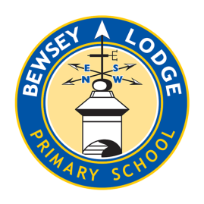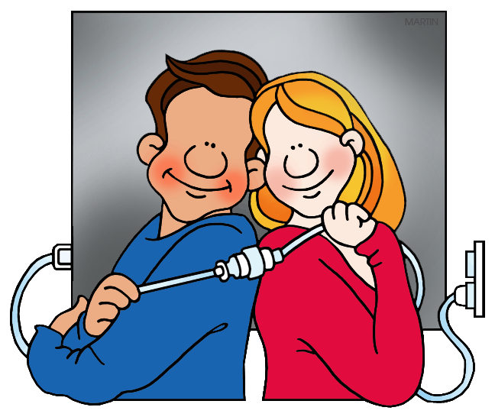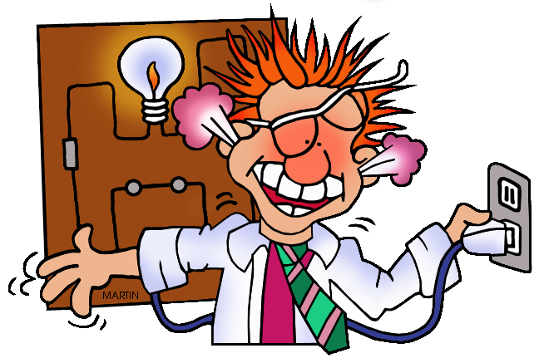

***Choose your homework from the grid below:***

You can choose as many tasks as you like. If you need a book or paper to record your work, just ask. You have the whole half term to choose and complete.

Return on **Monday 14th July** for marking and a reward ☺

Try to attempt **at least one** task from the top line ☺

**Amethyst – Fizzics**

|  |  |  |
| --- | --- | --- |
| Write an explanation of Sir Isaac Newton’s ‘Rainbow’ or colour theory.  ***Make it informative and include images to help explain how light works.*** | Write a formal letter to Mrs Wright highlighting the importance of saving power and switching things off when not needed.  ***Use a letter layout, remembering key features.*** | Make an eBook or PowerPoint presentation about animal eyes and how animals see, using drawing, pictures and/ or photographs. |
| Make a ‘lemon’ battery.  ***Find information on YouTube and ask an adult to help.*** | Make a shadow puppet to show in class.  ***No rabbits allowed ☺*** | Create an information/warning poster telling people how to stay safe around mains electricity.  ***Carefully consider the potential hazards.*** |
| Electricity is expensive - make two separate lists of battery and mains powered items in your home.  What type of batteries are used?  ***Punctuate your lists correctly.*** | Do you have a Smart Meter? Record your daily electricity use over a week and create a line graph.  ***Remember to label each axis.*** | Create 10-15 challenging quiz questions about electricity.  ***Write the questions with correct answers*.** |
| Research some optical illusions and then bring them in to share. | Make up a mnemonic to help you remember the order of the colours of the rainbow.  ***e.g. Richard Of York Gave Battle In Vain.*** | On a sunny day take pictures of your shadow at two hourly intervals. Why does it change? Why don’t shadows have colour?  ***Send images to***  [***amethyst@bewseylodge.co.uk***](mailto:amethyst@bewseylodge.co.uk) |

