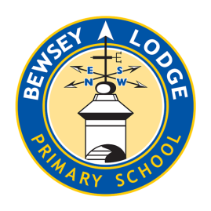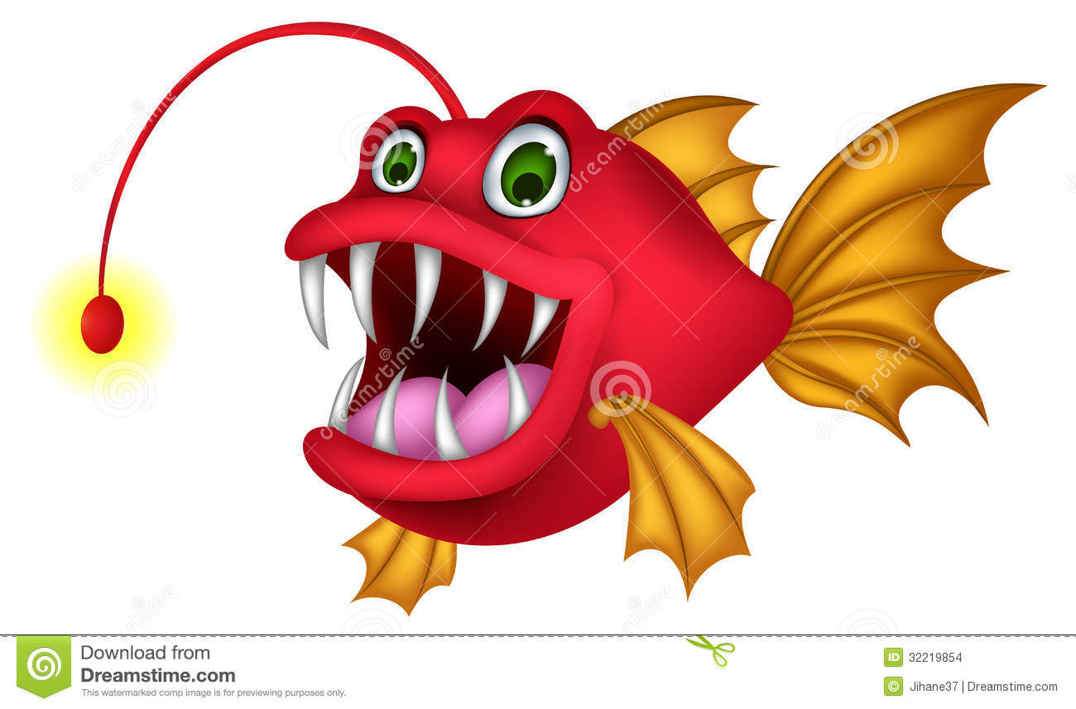

**Amethyst –River Monsters**

***Choose your homework from the grid below:***

You can choose as many tasks as you like. If you need a book or paper to record your work, just ask. You have the whole half term to choose and complete as much as you can.

Return on **Monday 20th October**  for marking and a reward ☺

Try to attempt **at least one** task from the top line ☺

|  |  |  |  |
| --- | --- | --- | --- |
| Write a description about a deadly river monster. Think about: what it looks like, how it moves, habitat, diet and the deadly traits it has.  ***Don’t forget expanded noun phrases. Draw a picture too.*** | If you have been on a trip or out for the day. Write a recount of what you did and how enjoyable it was.  (Did you walk along a river?)  ***Remember to use adverbials that show the passing of time.*** | Find out what freshwater animals are edible and prepare a set of instructions (recipe) of how to cook and prepare it for a tasty meal.  ***You could include a quotes from a friend saying how good it is.*** | |
| Create a drawing/painting of a freshwater animal. It could be a river dolphin, a crab, piranha or an otter! We’ll display it in class so take your time and colour carefully. | Find the world’s ten longest rivers and put them in order from longest to shortest.  ***Use the internet to research.*** | Make a river - it might look like this. Use old/unwanted things from around the house. |  |
| Create a leaflet that advertises a river holiday. It could be cruising up the River Nile.  ***Use colour to attract your reader’s attention.*** | Read a story and write why you would recommend it to a friend and give your personal point of view.  ***We’ll display it in our reading area!*** | Create 10-15 challenging quiz questions about rivers.  ***Write the questions with correct answers separate.*** | |
| Using a blank world map, draw and label where the world’s longest rivers are.  ***Use mapping symbols if you can.*** | Create a word search with words associated with rivers.  ***e.g. delta, meander, tributary, flood bank.*** | Create a sculpture/model of a fossilised fresh water creature.  ***Use the internet to find out what materials you can use.*** | |





