

**Key Knowledge**

Components of a Circuit and Their Symbols

lamp/bulb

(indicator)

wire

lamp/bulb

(lighting)

motor

switch

(open)

M

buzzer

cell

switch

(closed)

*battery*

These symbols can be used to create electrical circuit diagrams.

|  |  |
| --- | --- |
| **Key Vocabulary** | |
| **circuit** | **A path that an electrical current**  **can flow around.** |
| **symbol** | **A visual picture that stands for something else.** |
| **cell/battery** | **A device that stores energy as a chemical until it is needed. A cell is a single unit. A battery is a collection of cells.** |
| **current** | **The flow of electrons, measured in amps.** |
| **amps** | **How electric current is measured.** |
| **voltage** | **The force that makes the electric current move through the wires. The greater the voltage, the more current will flow.** |
| **resistance** | **The difficulty that the electric current has when flowing around a circuit.** |
| **electrons** | **Very small particles that travel around an electrical circuit.** |

**Significant Scientists:**

* **Benjamin Franklin – Electromagnetism – 1752**
* **Michael Faraday – Motors and generators - 1822**
* **Nikola Tesla - The AC Induction Motor – 1887**
* **Thomas Edison – The Electric Light Bulb - 1879**
* **James Clerk Maxwell - The Wireless Telegraph - 1897**

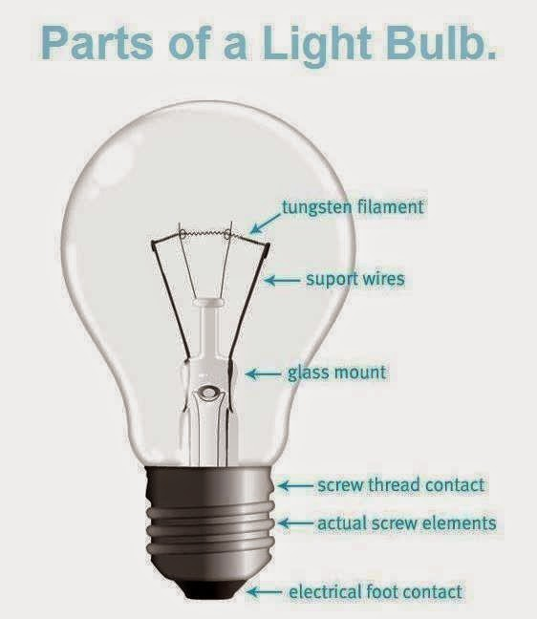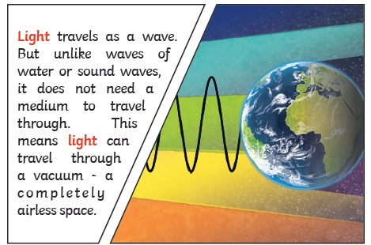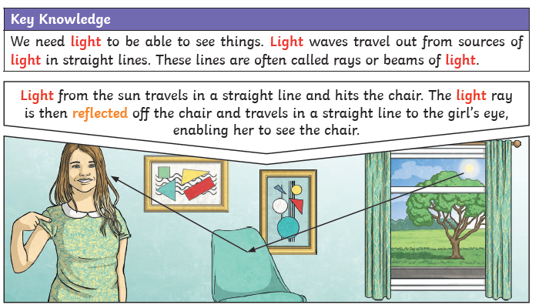

|  |  |
| --- | --- |
| **Key Vocabulary** | |
| **refraction** | **This is when light bends as it passes from one medium to another. E.g., Light bends when it moves from air into water.** |
| **visible spectrum** | **Light that is visible to the human eye. It is made up of a colour. spectrum.** |
| **prism** | **A prism is a solid 3D shape with flat sides. The two ends are an equal shape and size. A transparent prism separates out visible light into all the colours. of the spectrum.** |
| **shadow** | **An area of darkness where light has been blocked.** |
| **transparent** | **Describes objects that let light travel through them easily, meaning you can see through the object.** |
| **translucent** | **Describes objects that things let some light through, but scatters the light so we can’t see through them properly.** |
| **opaque** | **Describes objects that do not let any**  **light pass through them.** |

**Significant Scientists:**

* **Isaac Newton – The Colour of Light – 1660s**
* **Johann Zahn - The Camera – 1685**
* J**oseph Nicephore Niepce – The First Photograph – 1814**
* **Thomas Edison – The Light Bulb - 1879**
* **Percy Shaw – Cat’s Eyes - 1934**