Create a fact file about an animal that lives in the Arctic. | Create a collage of some Arctic animals. | Use a world map to locate the Arctic and Antarctic. | Find out about the impact global warming is having on the Arctic. ice.
Design a menu for a polar bear. | Write a story or diary entry as if you lived in a very cold place. | Borrow some books about the arctic from the library. What can you find out about life in the Arctic? | What would you take with you on your journey to the Arctic? Write a list of important things you might need and why.
Compare the size of a polar bear’s paw to your hand. What is the difference? | Make an Arctic animal mask. | Design a poster to warn people of the effects of global warming. | Make your own igloo using recycling and materials you can find around the house.
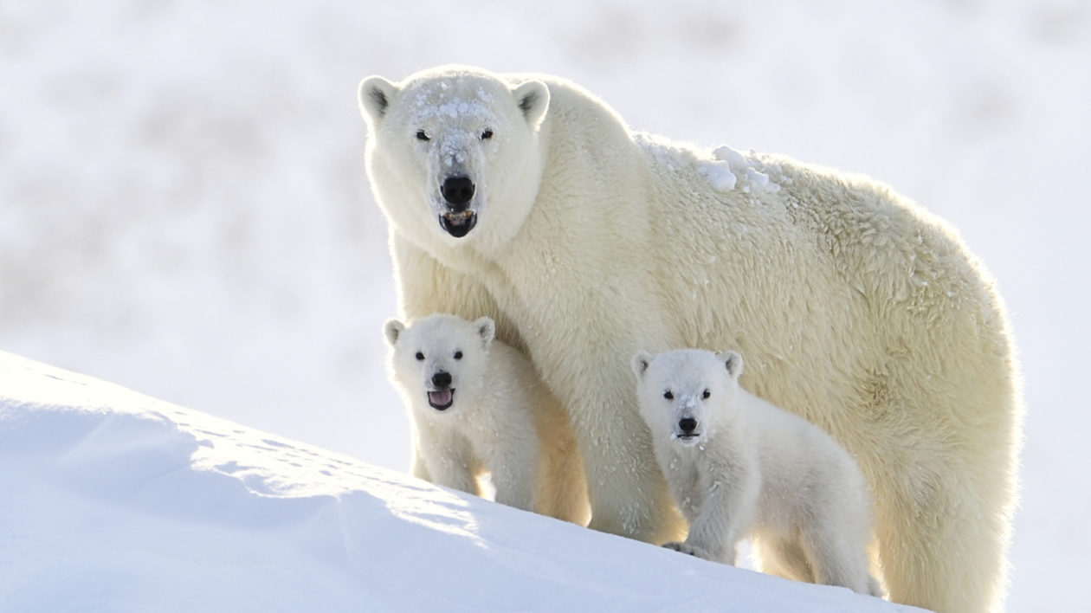
Year Two Homework for Autumn 2 Half Term
What?
You can choose as many tasks as you like, recording any writing in your homework book. Don’t forget to take pictures, too!

When
You have over the whole half term to complete. Return week beginning 16th December, 2024 for marking and a reward!

