Why is Old Billy important?
- He lived much longer than most horses.
- His story teaches us about animal welfare and how we treat working animals
- Take a walk along New Cut Canal to see the Old Billy Trail
- new cut trail – The official website for the New Cut Heritage & Ecology Trail Group

Year 2 - Knowledge Organiser
The Tale of Old Billy
Children will learn about Old Billy, the world’s oldest recorded horse, and look at the changes that have taken place in Warrington since his time. Through Talk for Writing, they will write persuasive letters and poetry to honour his legacy.

Key Vocabulary
Barge horse – a horse used to pull boats along canals
Canal – a man-made waterway for boats
Transport - ways of travelling
Mersey Flat – a type of boat with a flat bottom, pulled by a horse
Industrial Revolution – a time in history when lots of factories began to be built and lots of people went to work in them
Plough – a tool used to break up soil, pulled by people or horses
Gin – a large wheel turned by a horse, this can then operate a machine

Who was Old Billy?
- Old Billy was a barge horse from Warrington, England.
- He was the oldest recorded horse in history, living for 62 years (1760–1822).
- He worked pulling boats along canals for most of his life.
- His skull is kept in Manchester Museum.

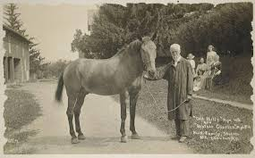

What was life like for working horses?
- In the 18th and 19th centuries, horses were used for heavy work,
such as farming, transport, and pulling barges.
- They had to work long hours in difficult conditions.
- Today, horses are often kept for riding and sports instead of hard labour.

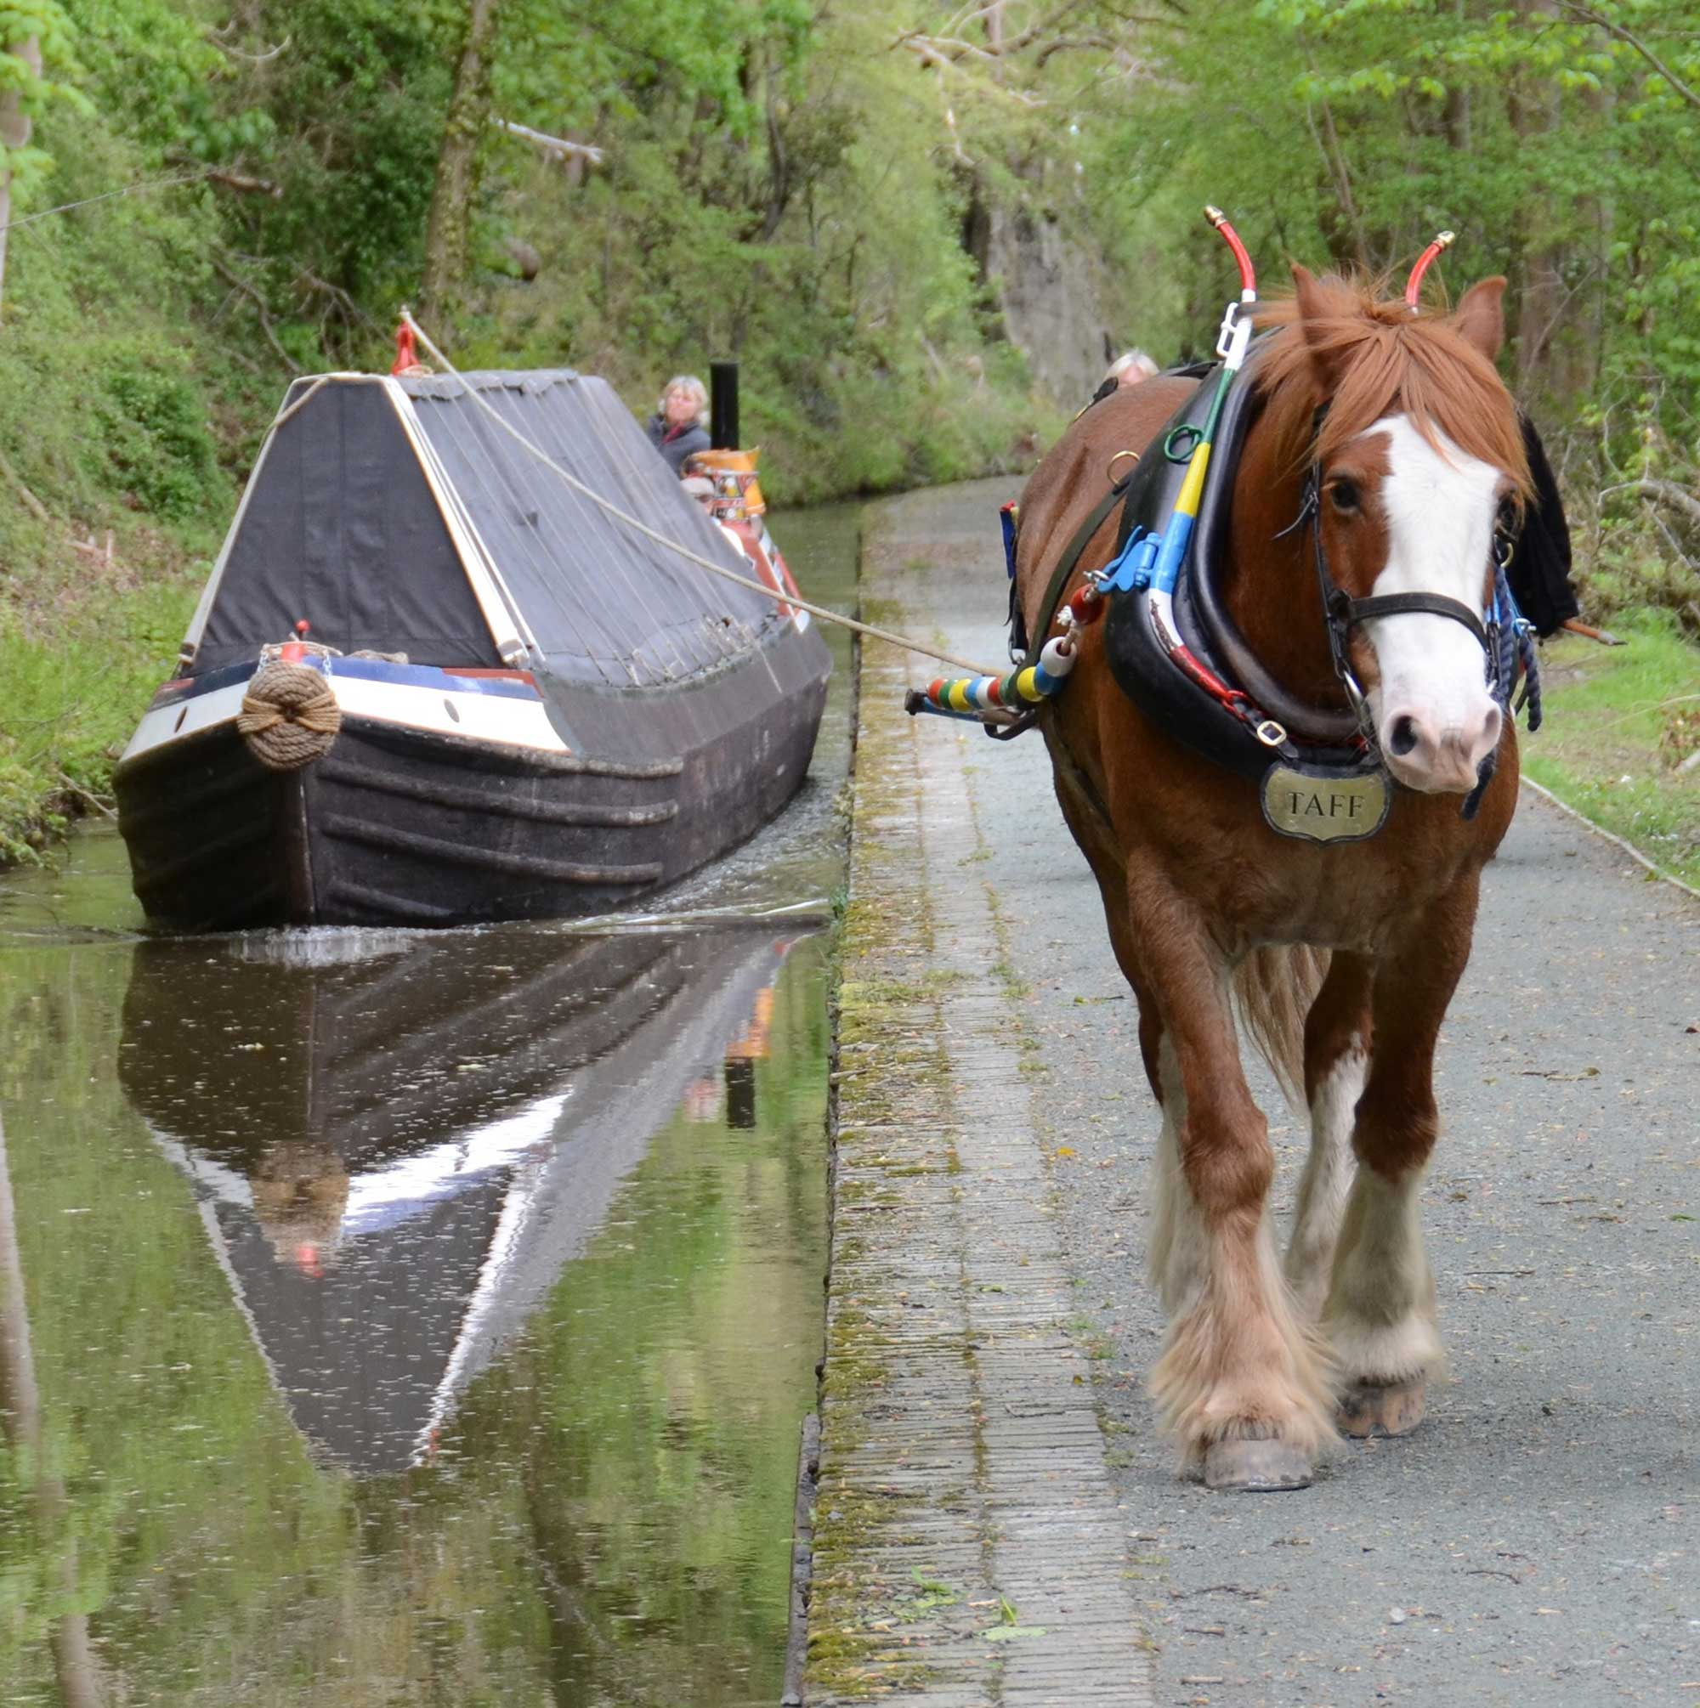

Old Billy was born in Woolston Worked at the Bridgewater Canal Retired at 59 years old Old Billy died at 62 years old
1822
1821
1819
1790ss
1760
Old Billy is bor
1810
1778
Started working as a barge horse at 18 years old Celebrated 32 years of work Painted by artist Charles Towne

