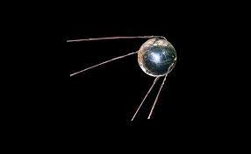

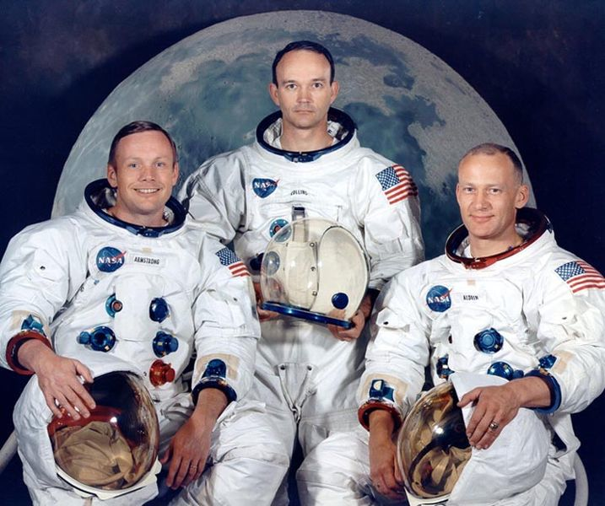
Have sent it
Topic overview
In this History topic, we will be exploring our Solar System and finding out about space.
Key events

October 1957 Sputnik was launched in to Space by the Russians.

12th April 1961 Yuri Gagarin, a Russian astronaut, was the first man in space. Gagarin's spacecraft, Vostok 1, completed one orbit of the earth, and landed about two hours after launch.

20th July 1969 the American astronauts landed on the Moon. The team consisted of Neil Armstrong, Buzz Aldrin and Michael Collins.
Key people
Neil Armstrong
1930-2012
An American astronaut and
the first man on the moon.

Buzz Aldrin
Born in 1930
An American astronaut who
was the second person to step
foot on the moon.

Michael Collins
Born in 1930
An American astronaut and
Pilot of Apollo 11.

Yuri Gagarin
A Russian astronaut who
became the first man in
space.

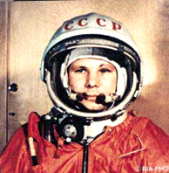
Key Vocabulary

Astronaut - a person who is trained to go into space.
Planet – a large round object that moves around the sun.
Solar System – the sun and the planets that go around it.
Gravity – a force that pulls things down and keeps the planets in place.
Space – the area beyond Earth, above the sky
Rocket – a vehicle that travels into space.
Comet – a ball of ice and dust that moves through space and can have a glowing trail.
Astronomer – a person who studies space.
Astronomy – the study of space and thins in space.
Orbit – the path a planet or moon follows as it goes around something.


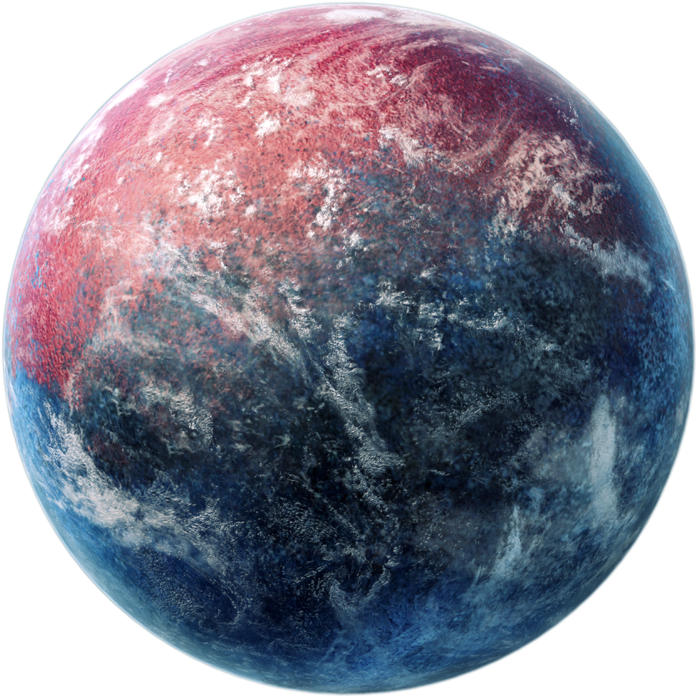
Interesting facts
- Space is completely silent.
- Nobody knows how many stars there are in space.
- There is water floating in space.
- One million earths could sit inside the sun!
- The sun is considered a star.
- If you could fly a plane to Pluto, it would take 800 years!
- The sunset on Mars appear blue.

20th July 1969
The Americans win the race! Neil Armstrong and Buzz Aldrin are the first men on the moon!
12th April 1961
Russian astronaut
Yuri Gagarin was
the first man in space!
November 1957
Laika the dog goes to space!

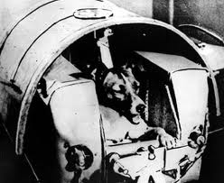
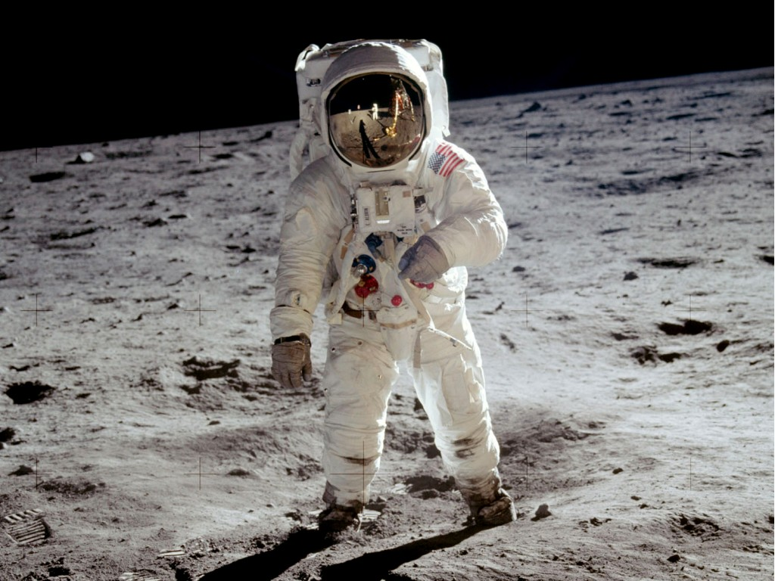
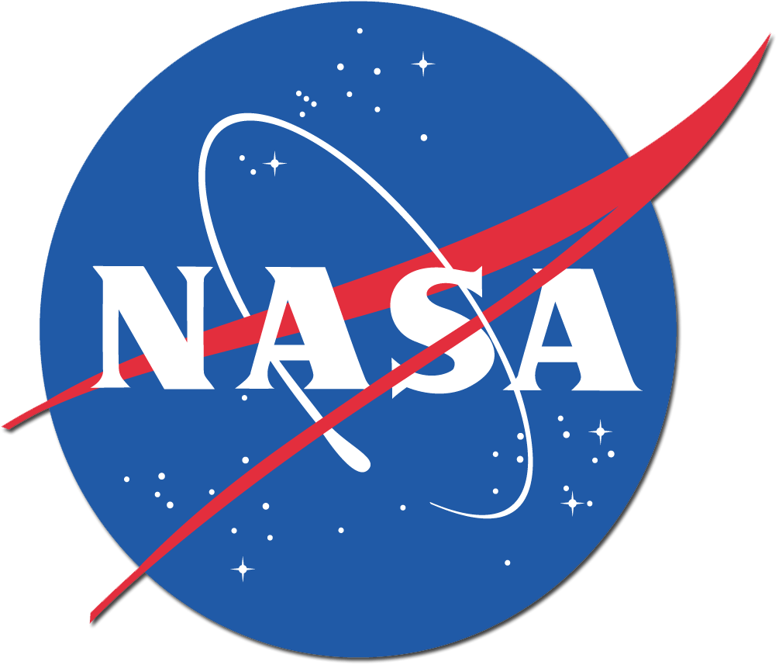
Our Timeline

2023 - Now

1900 1950 2000
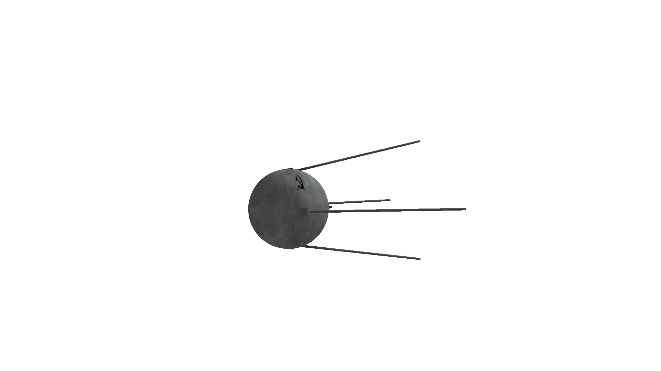
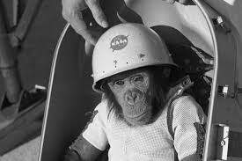
January 1961
Ham the Chimpanzee was the first animal that proved that humans could carry out tasks in space.
October 1957
Sputnik – the Russian satellite – is launched!
When Neil Armstrong took his first step on the moon, he said
“ that’s one small step for man… one giant leap for mankind”

