Diamond Class - Homework Autumn 2
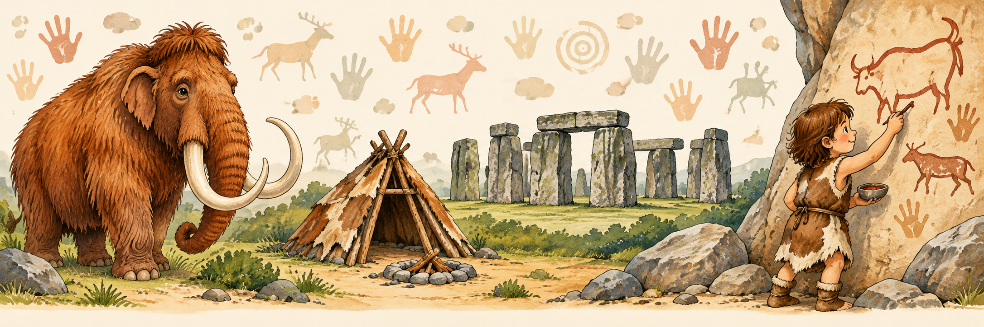
Cave artist  Draw a cave picture using brown, black and red colours. Include animals and people. Can someone at home work out what your picture shows? | Stone Age shelter  Build a miniature shelter using twigs, leaves, cardboard or recycled materials. Explain how it would keep your family warm and dry. | Rock detective  Find three different stones. Draw them and describe their colour, texture and shape. Which would you choose to make a pretend tool, and why? | Stone Age suitcase  Draw five things you would take if you travelled back to the Stone Age. Explain why each would be useful!
Then and now  Fold a page in half. Draw a Stone Age home on one side and a modern home on the other. Label three differences. | Stonehenge builder  Make your own Stonehenge using building blocks or cardboard. Can you balance a piece across two upright pieces? | Stone Age menu  Create a menu for a Stone Age hunter-gatherer family. Include foods they could hunt, fish for or gather. | A day in my life  Imagine you are a Stone Age child. Write a short diary entry about your day, or record yourself telling us about it.
Tool inventor  Design a Stone Age tool. Draw and label it, showing what it is made from and what it does. You could make a cardboard model. | Hunter’s maths  Make up a Stone Age maths problem and show the answer. For example: Four hunters catch three fish each. How many fish altogether? | Ask an archaeologist  Draw an object that might survive from the Stone Age. What could it tell us about the people who used it? | Stone Age comic  Create a four-picture comic about a Stone Age adventure. Perhaps your character spots a mammoth or discovers a cave!

You can choose as many tasks as you like! If you need paper to record on, just ask! Some tasks are more of a challenge, so you can earn extra diddy-dots!
You have over the half term holidays and during Autumn 2 half term to complete the tasks. Return for Monday 14th December for marking and a reward!

