Topic overview – Superheroes!
This half term, we will be writing stories based on superheroes! Here are some of the features we will need to think about including in our writing to make it super!
Onomatopoeia – Sound words!

Adjectives to describe a Superhero!

brave, courageous, fast, reliable, powerful, smart, mighty, commanding, rapid, wise, confident, daring, fearless, extraordinary, proud, responsible, adventurous, bold, admirable.

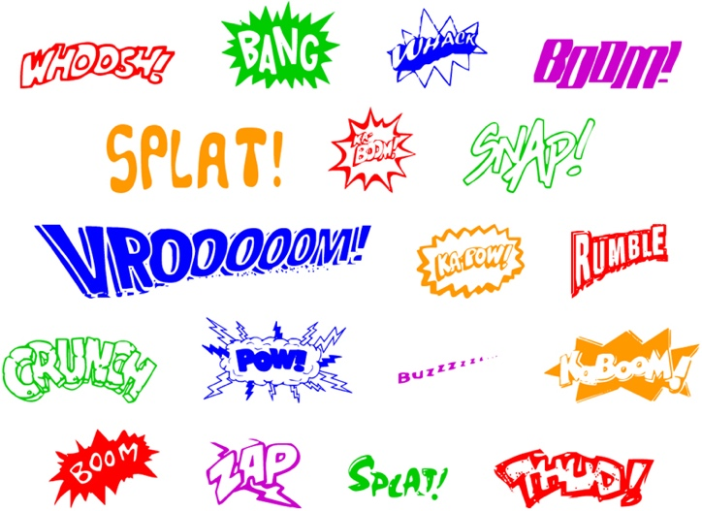
Super sentence
starters!

As quick as a flash,
Without warning,
Unexpectedly,
In the blink of an eye,
Seconds later,
Rapidly,
In an instant,
All of a sudden,
Silently,
As fast as they could,
Courageously,

Double inverted commas for speech!

“Help! Help! I’m stuck!” bellowed the young girl.
Remember – the double inverted commas go around what the person says and the punctuation! A reporting clause is used to let the reader know who said it.

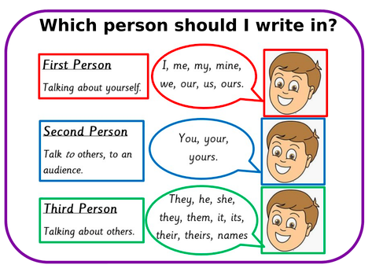
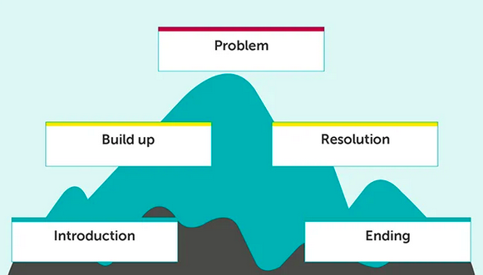

Story Mountain

