Topic overview
In this topic children learn all about the comparisons between the UK and Spain. We will explore the similarities and differences in how people live, eat and enjoy themselves as well as comparing the land and produce in both countries.

UK | Spain
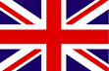 | 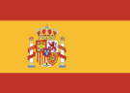
Capital city –  LONDON | Capital city - MADRID
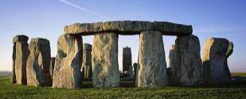  Key landmark –  STONEHENGE | Key landmark –  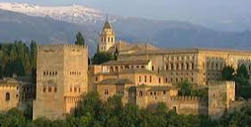  THE ALHAMBRA
A key river -  RIVER MERSEY | A key river -  GUADALMEDINA
High ground –  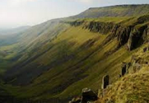  PENNINES | High ground –  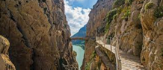  CAMINITO DEL REY ROUTE
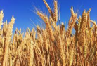  Produce - wheat | 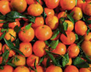  Produce - oranges
Map of Warrington and Malaga

Can you spot the airport?
Is the train station in Warrington or Malaga?
Where are the rivers and seas located?
Do they both have roads?
There is a hospital in both, can you spot them?
Key Vocabulary
Continent – a large, solid area of land. Earth has seven of them.
Country – land that is controlled by a single government.
Capital city – A city where the government of that country is based.
Europe – A continent.
UK – the United Kingdom of Great Britain and Northern Ireland.
Malaga – A port city and resort in Andalusia in southern Spain.
Human features – houses, roads and bridges.
Physical features – seas, mountains and rivers.
Produce – farm produced crops.
Import – goods that are produced in one country and shipped to another country for sale.
Export – goods that a country buys from another country.

