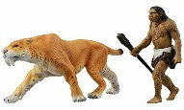
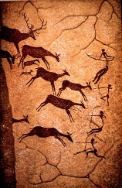
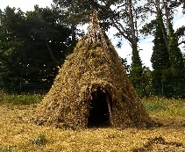
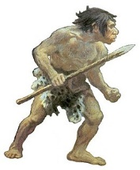
Topic overview
In this topic children learn all about the Stone Age and how people used to live during this period and into the Iron Age.

Tools and weapons
The Stone and Iron ages saw humans using tools to help them survive and make weapons for hunting for the first time. Learn the following words and their meanings and they will help you with your historical study…
spear arrowhead flint chopper

cleaver scraper hand-axe

nets harpoons hammer-stone

catapult bow slingshot

Key images
Palaeolithic man
(Stone Age Man) A cave painting

A Stone Age home

Cooking an animal Preparing and cooking fish

Starting a fire

Using a spear A tribe – Stone Age community Preparing an animal skin

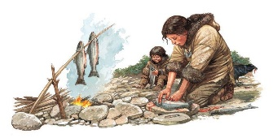
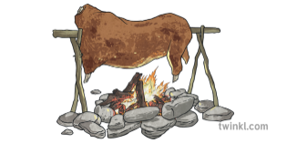
Key Vocabulary
Chronological – in the order that things happened.
B.C – the time before Christ was born.
A.D – the time after the death of Christ (Anno Domini).
Archaeology – the study of artefacts from the past.
Historical evidence – anything from the past which gives us clues about what life was like.
Hunter-gatherer – humans who provide food, clothing or shelter by hunting animals or gathering things from the natural environment.
Farmer – someone who grows crops or keeps animals to provide food or materials.
Settlement – a place where people create a community.
Tribe – a group of humans who share a common culture or language – often with just one leader.
Period – a point in time.

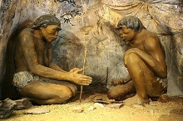
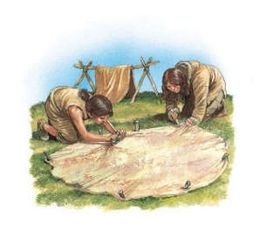
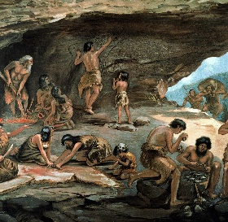
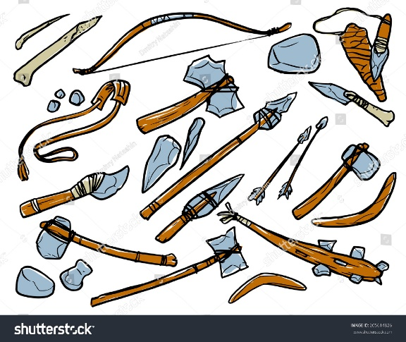
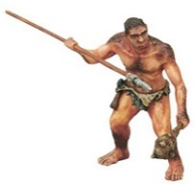

Food Facts
- They moved from place to place to find food; often living in temporary shelter.
- They had to find what they ate – everyday.
- Any animal they could catch and kill would be eaten e.g., bears, mammoth, tiger, deer and boar.
- They gathered fruits and nuts from trees, plants or from the ground.
- Hunted fish and shellfish with a harpoon.
- They even ate the roots of plants!

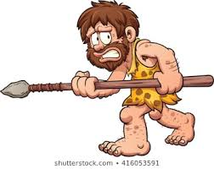

The birth of Jesus
Our Timeline

The Stone Age
2,500,000 –
2,300BC

1912- The Titanic sets sail.

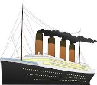


Dinosaurs 800BC 1800 1900 2000

2,500,000 – 2300BC 2500BC
The Bronze Age
2500BC - 800BC
2025- Now

1819 – 1901 Victorian times

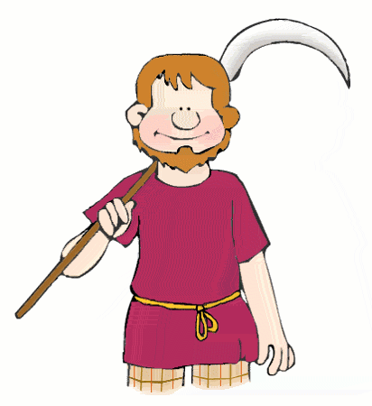
The Iron Age
800BC –
43AD

