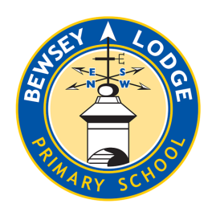
Beside the Sea: A Coastal Study

Choose your homework from the grid below:
You can choose as many tasks as you like. If you need a book or paper to record your work, just ask. You have the whole half term to choose and complete as much as you can.
Return before Monday 20th July for marking and a reward.
Research a coastal environment to show the positives and problems that natural processes can cause e.g. erosion.  You can be creative e.g. draw a cartoon, storyboard or write a script or newspaper report about a particular event. | Write a fact file about an animal that lives along the U.K. coastline. | Create a 3D model of a coastal area. Make sure you label the features!
Using your knowledge of coastal landforms, create your very own edible landform. Take a photo and annotate it to show which landform is which! | Create a comic strip which shows the transition of a cliff into the different coastal features (such as an arch). | You could visit the beach and take lots of pictures of the coastal features whilst you are there.
Create a poster to persuade people against plastic pollution. | Create a collage showing the power and danger of the sea. | Write an acrostic poem for the word ‘COAST’.
Create a word search including 10 key words you have learnt from our topic. | Create a geography dictionary on coastal key words that could be used to teach a future class. | Read a book and write a review. What did you like about it? What did you dislike? Would you recommend it to a friend?

