A coast is a strip of land that meets an ocean or sea.  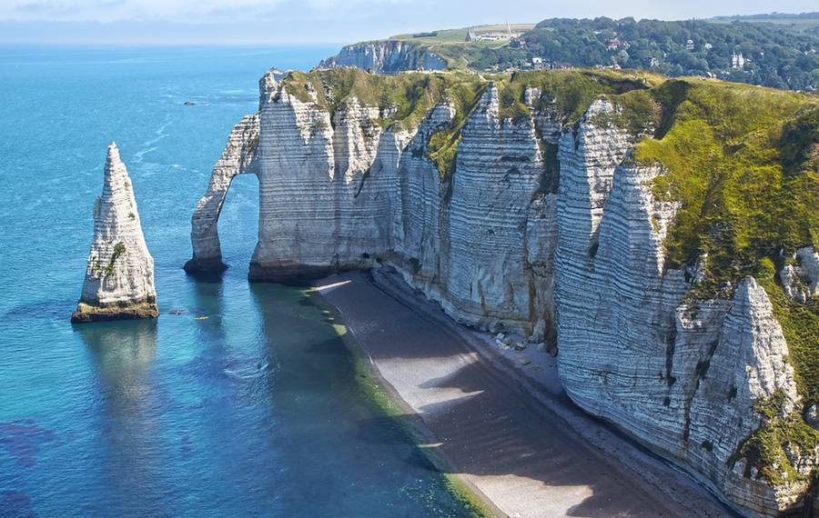  There are many different types of coast which include cliffs, beaches, salt marshes and sand dunes.  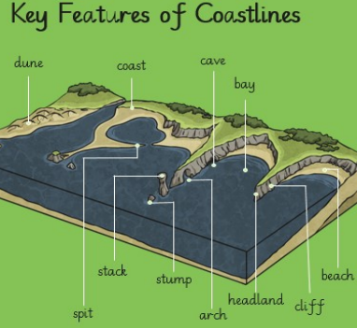  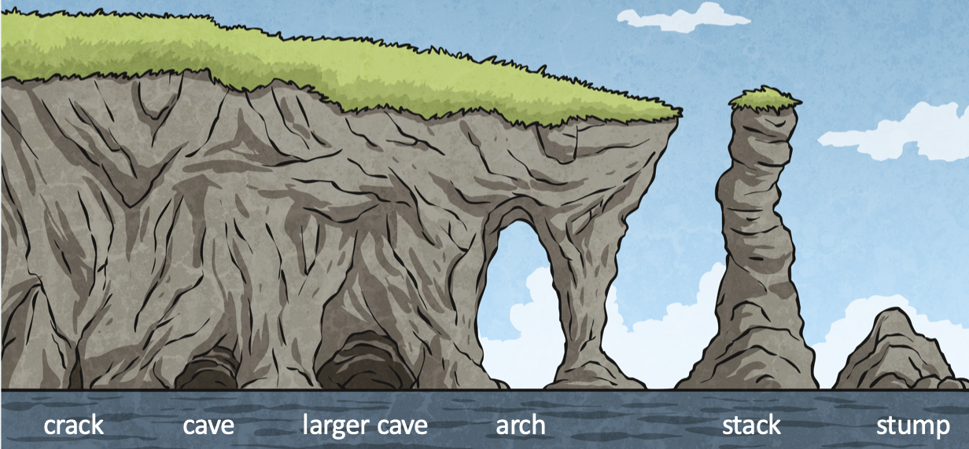 | dune | a hill of sand near the beach or in a desert | 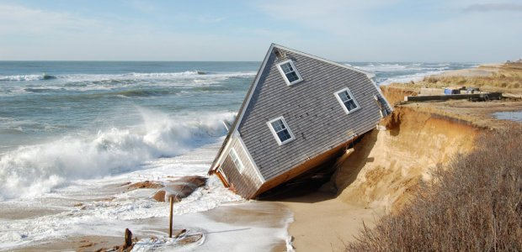  Erosion is the wearing away of the land by forces such as water, wind, and ice. Erosion has helped to form many interesting features of the Earth's surface including coastlines. It can also have consequences…  Our coastal wildlife:  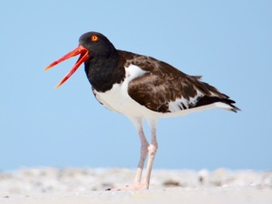  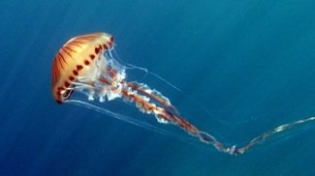  Jellyfish  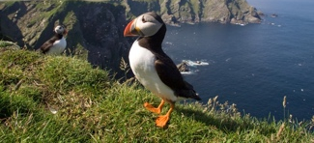  Puffin  Oystercatcher  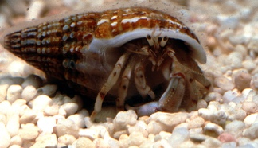  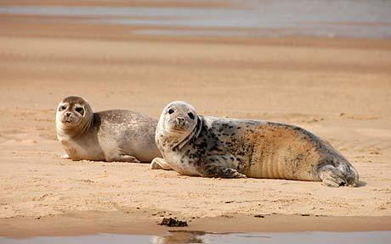  Harbour seal  Hermit crab  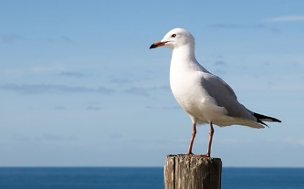  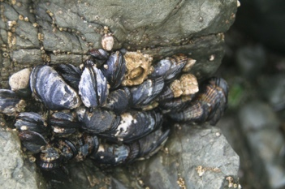  Seagull  Mussels  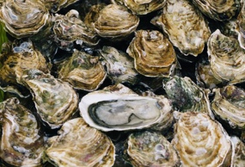  Oysters
 | coast | where the land meets the sea
 | spit | a long, flat beach
 | stack | a tall rock sticking out of the sea
 | stump | this is made when a stack falls over
 | arch | an opening in the cliff face
 | cave | a large hole in the rock
 | bay | a curved part of the coast
 | headland | a piece of land that sticks out from the coast
 | cliff | a very high area of rock
 | beach | sand or stones near the sea
 | destructive waves | Destructive waves destroy the coast by removing material away.
 | constructive waves | Constructive waves place sediment (sand, rocks, pebbles etc.) down by the coast, adding to it.
Besides the sea – Knowledge Organiser

