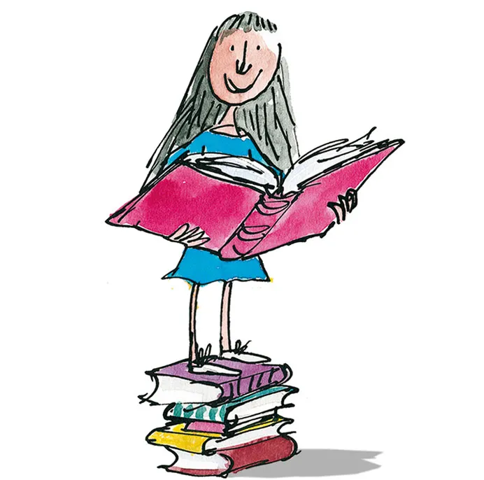

Choose your homework from the grid below:
You can choose as many tasks as you like. If you need a book or paper to record your work, just ask. You have the whole half term to choose and complete.
Return on Monday 18th May for marking and a reward

Year 5/6 – Marvellous Matilda

Write a character description of Matilda. Include her personality, appearance, and what makes her special. | Design a new book cover for Matilda. Think about key events and characters and add illustrations. | Write a diary entry as Matilda on her first day at school. Remember to include her thoughts and feelings about Miss Trunchbull.
Imagine you are Miss Trunchbull. Write a set of school rules.  Remember… she is very strict! | Write about a time when you stood up for what is right, like Matilda. | Create a “Wanted Poster” for Miss Trunchbull.  Include: crimes, description, and a reward!
Create a quiz about Matilda. Include at least 15 questions and an answer sheet. | Turn a scene from the story into a comic strip with speech bubbles. | What if Matilda’s powers went wrong? Write a short story about the chaos!
Imagine YOU had telekinesis like Matilda. What would you do? Write a story to describe what happened. | Make a chocolate cake like Bruce enjoys so much. Take a picture and share it in class. | Create a fact file or biography about Roald Dahl.

