Important Facts

A farm is a piece of land used to grow crops and/or raise animals for produce.

Arable farming is when plants are grown on farms.

Livestock farming is when animals are bred on farms.

We get a lot of the food we eat from farms.

Harvest is when farmers cut down the crops they have grown to sell.

Key vocab

agriculture, field,
livestock, hay,
arable, herd,
crops, milking,
harvest, barn,
tractor, dairy,
combine harvester,
plough,
vegetables

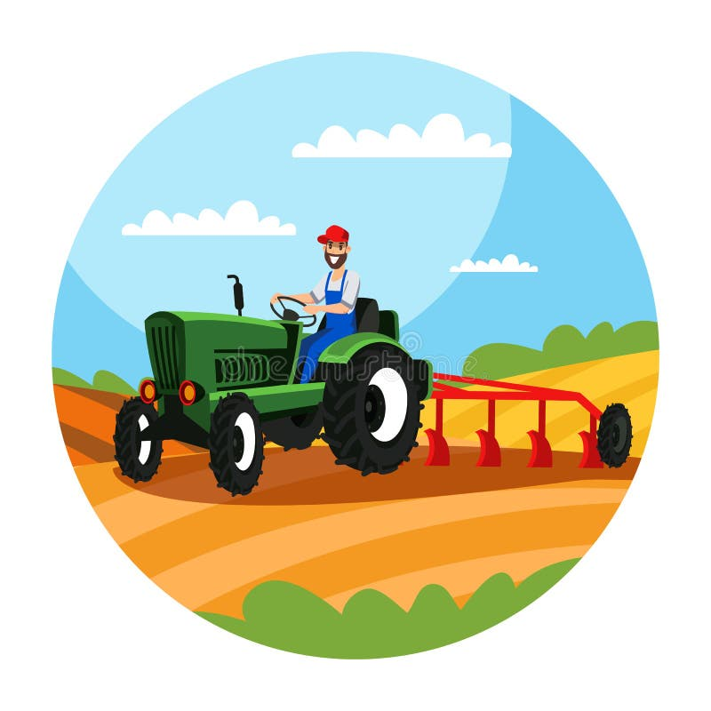

Farming
(Autumn 1)
Researching the topic

https://www.foodafactoflife.org.uk/5-7-years/where-food-comes-from/videos/

https://www.bbc.co.uk/bitesize/topics/zg69g7h

It’s Milking Time by Phyllis Alsdurf

Meet Pete by Jennifer Campbell

Clarabelle by Cris Peterson

All non-fiction books on farming and growing food.

Meet Pete by Jennifer Campbell

Clarabelle by Cris Peterson

Geography Skills

To explore what farms are and why they are important.
To explore the features of a farm.
To explore the differences between life on a farm and life in a city.
To be able to use a map to navigate around a farm.
they are important.

Places to visit
Tatton Park,
Smithills Farm,
Kenyon Hall Farm,
Fruit picking,
Supermarkets,

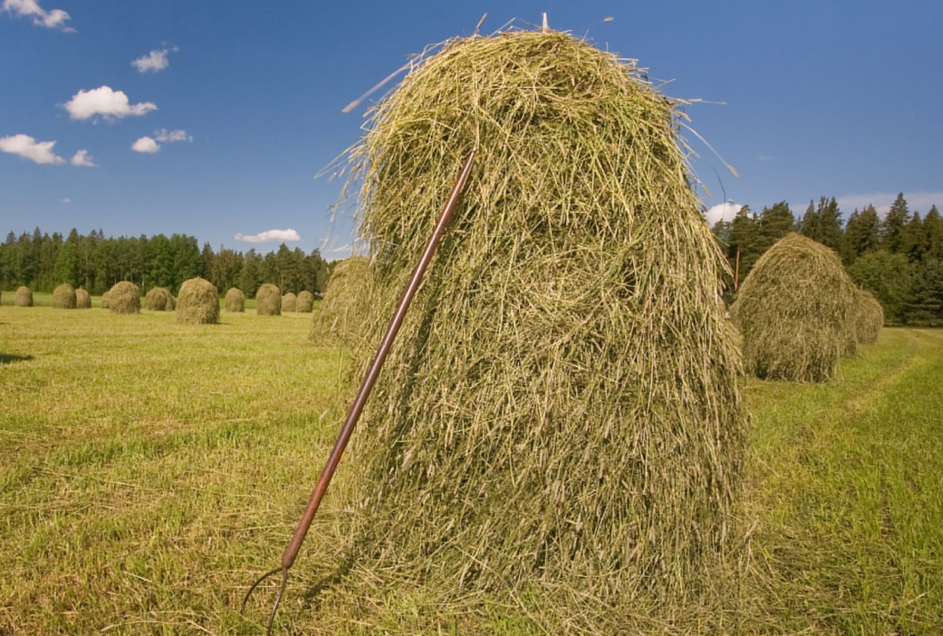
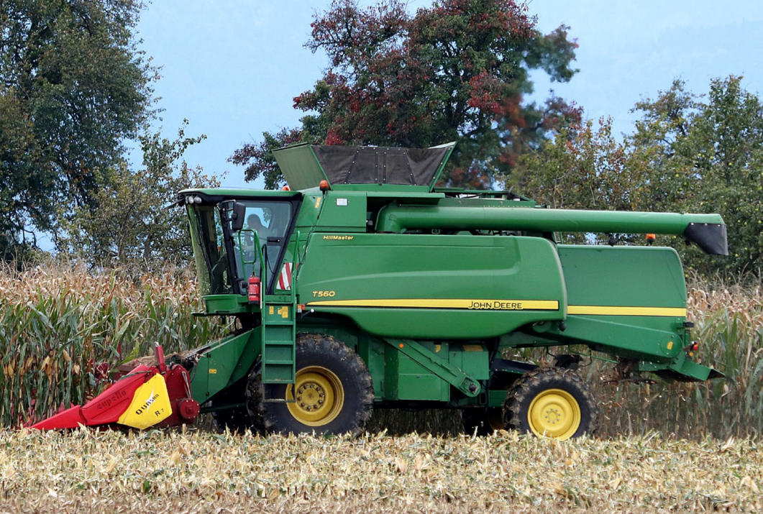
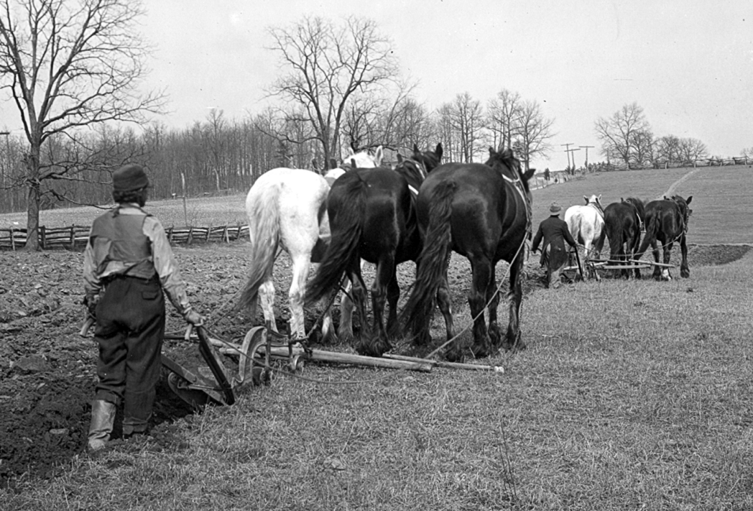
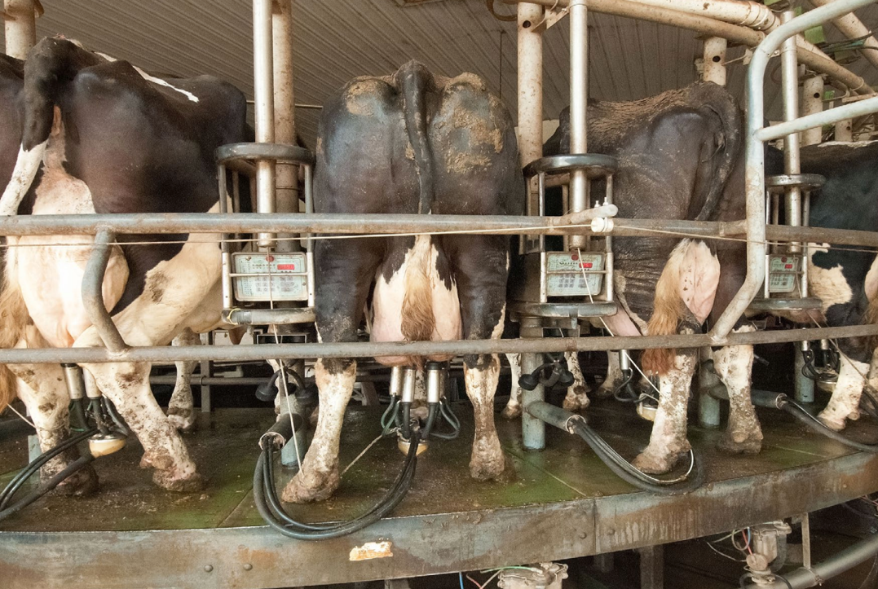
Pictures to share with an adult and discuss what you can see.

