Important Facts
- A lighthouse isa tall building near the sea.
- The light helps ships see where they are at night.
- Lighthouses can warn ships about rocks and dangerous places.
- The light can be seen from far away.
- Some lighthouse lights spin or flash.
- Lighthouses can be different colours.
- Many lighthouses are round and tall.
- Lighthouses help ships when the weather is dark, foggy or stormy.
- A person who looks after a lighthouse is called a lighthouse keeper.
- Lighthouses are found in many countries around the world. and tall.

Key vocab

lighthouse light
lifeboat disaster
help rescue
sea ocean
rocks crash
save cliff
search telescope
Grace Darling

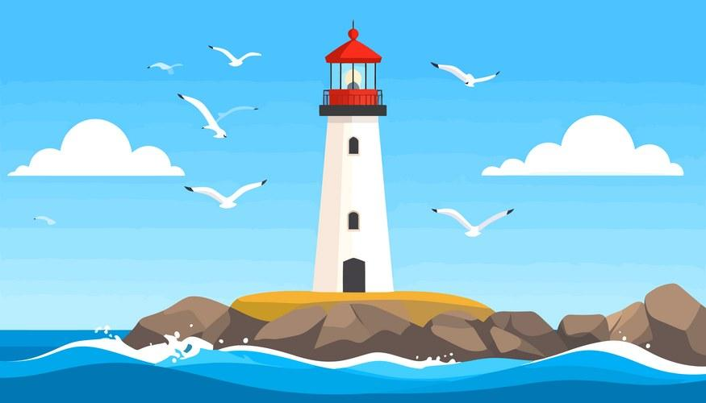
Lighthouses
(Autumn 2)
Researching the topic
https://www.youtube.com/watch?v=ZL_i4QL35iA

https://www.bbc.co.uk/iplayer/episode/b0bh1zqh/go-jetters-series-2-41-bishop-rock-lighthouse-isles-of-scilly

All the books in the Lighthouse keeper series by Rona and David Armitage.

Lifeboat Lucy by D Macdonald

A Lighthouse Story by Holly James

All non-fiction books on lighthouses, lifeboats and Grace Darling

Meet Pete by Jennifer Campbell

Clarabelle

Places to visit

- The beach
- The Hale Head Lighthouse
- The lifeboat centre at St Annes
- New Brighton Lighthouse

History Skills

To understand the effect a famous person has had on others.

PSHE / Citizenship Skills

To gain a greater insight into a particular role ie person working on the lifeboats.
they are important.

A picture to share with an adult and discuss what you can see

