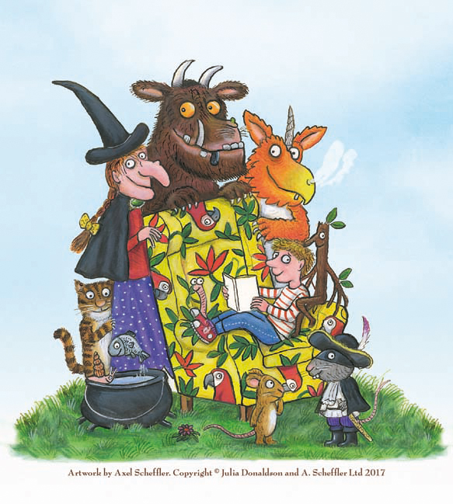
Gold Class’s Homework for Spring 2
Hand in on Monday 30th March
In order for your child to become more familiar with the stories we are studying, they could
watch the animations are on You Tube or BBC iPlayer.
Make a list of all the stories Julia Donaldson has written. Use the internet to help you. | Pretend to be the Stickman. Write a letter or postcard to your family telling them of your travels. | Look through the story of the Monkey Puzzle and read the different descriptions that little monkey gives of his mother.  Create a MISSING poster that could be nailed to a tree in the jungle, giving all of the different details of what she looks like (look at the descriptions of her size, tail, legs, fur etc.).  Remember to include information about where she was last seen and choose a reward that you would give if somebody/an animal found her.
Make groups of rhyming words.  E.g. cat, hat, bat  bright, flight, sight | Create some shadow puppets to scare away the Gruffalo.
 | Ask an adult to read a Julia Donaldson story to you. If you haven’t got one of her books, go on You Tube and find one of the stories being read. Rewrite it in your own words.
Write a spell the Witch from the Room on the Broom might cast. The stranger the better! | Make some cornflake cakes and decorate them to look like the Gruffalo. | Go for a walk in a forest looking for the Gruffalo or Stickman. Collect lots of different natural things. Use them to create a collage.

