Our new topic for Summer 2 is In the Spot Light where we will be learning about famous people from the past.

The people we will definitely be looking at are…

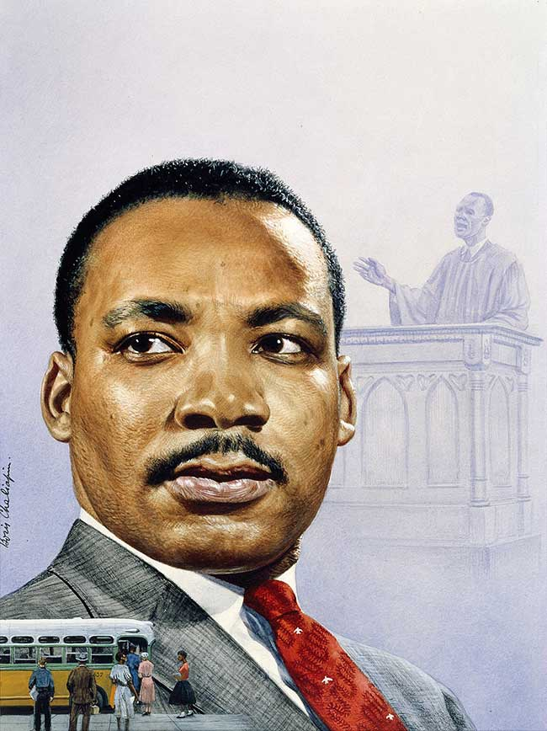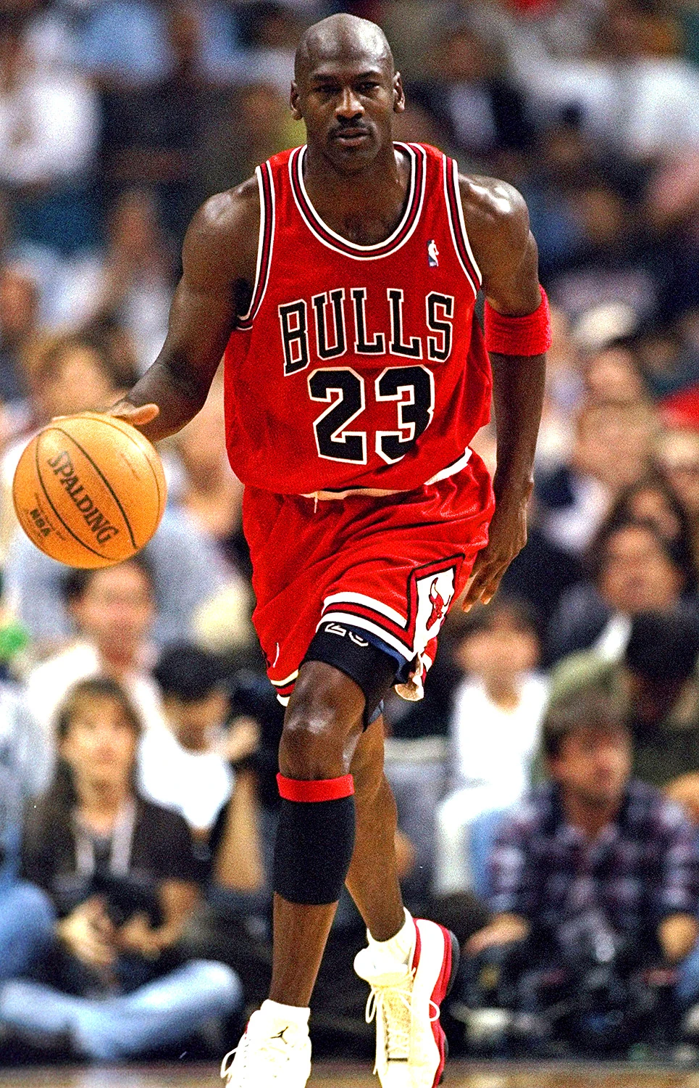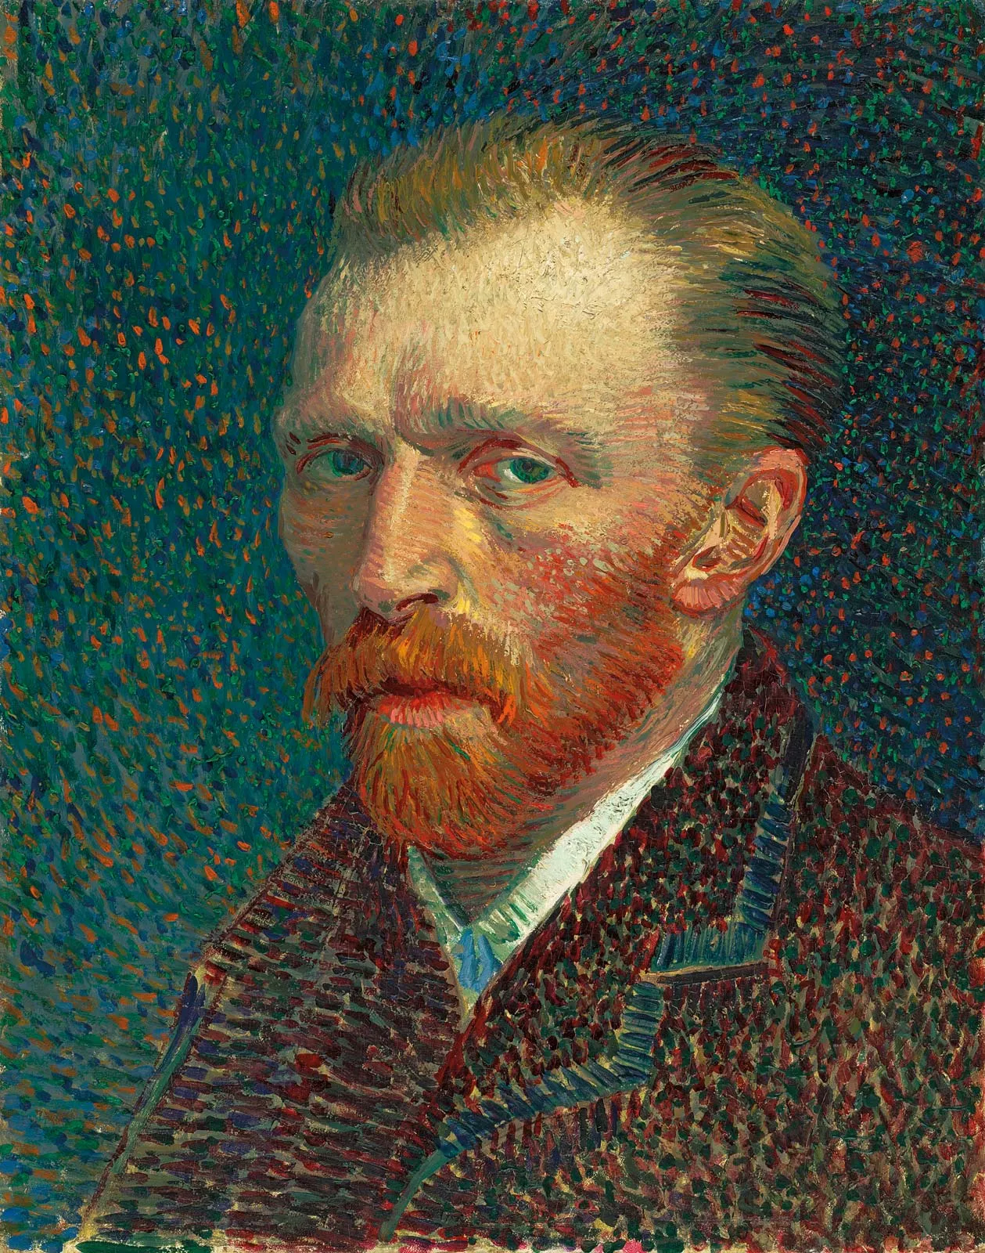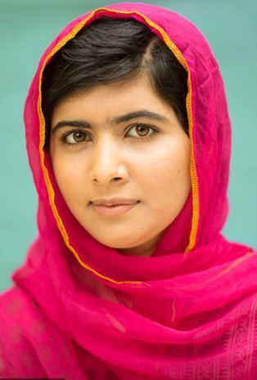

Michael Jordan

Malala Yousafzai

Martin Luther King

Vincent Van Gogh

As this is a history topic, we will be working on the following historical skills:

* Looking at information about things from the past.
* Comparing things in the past with things from now.
* Thinking about how things have changed over time.
* Putting things in chronological order.
* Looking at different real things from the past and talking about them.