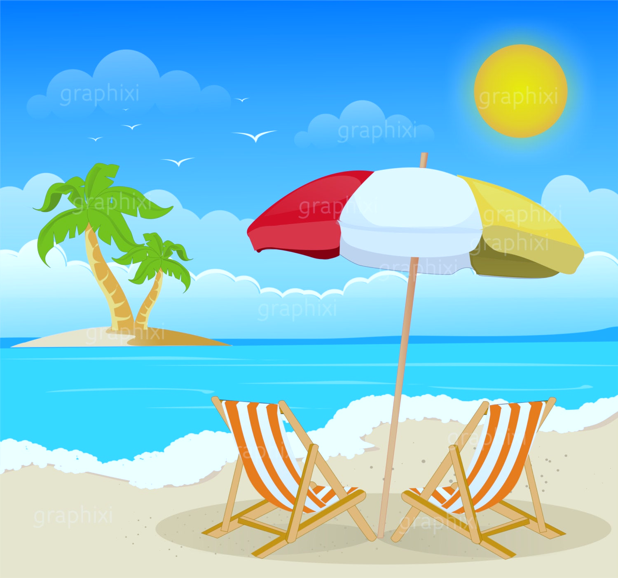**Year 1 Homework for Summer 2**

What?

You can choose as many tasks as you like. Don’t forget to take pictures, too!

When?

You have over the whole half term to complete. Return for week beginning Monday 14th July for marking and a reward!

|  |  |  |  |
| --- | --- | --- | --- |
| **Shell Counting** *Task:* Count how many shells, crabs or starfish are in a seaside picture. | **Seaside Shop** *Task:* Set up a pretend seaside shop. Use real or play money to “buy” ice creams, buckets, and spades. | **Seaside Animal Fact File** *Task:* Choose one seaside animal (e.g., seagull, crab, starfish) and draw it. Write 1–2 facts about it. | **What to Pack for the Beach?** *Task:* Draw and label things you would take to the seaside. |
| **Sandcastle Drawing or Model** *Task:* Draw or make a sandcastle using junk modelling or playdough. | **Seaside in a Shoebox** *Task:* Create a mini beach scene in a shoebox using materials from home. | **Seaside Walk or Virtual Visit** *Task:* Visit a beach or explore one virtually (using videos). Draw your favourite thing you saw and write a sentence about it. | **Seaside Word Hunt** *Task:* Find and write seaside-themed words that use phonics sounds. |
| **Label the Picture** *Task:* Label parts of a seaside scene (sun, sea, sand, boat, fish, towel). | **Ocean Sounds Drawing** Task: Listen to seaside sounds (waves, seagulls, splashing). Draw what you imagine. | **Create a Seaside Puppet Show** *Task:* Make puppets (fish, lifeguard, crab, surfer) from paper or socks. Create a short performance. | **Seaside Now and Then** *Task:* Look at old photos (or use printed ones) of beaches from the past and today. *Compare:* “What has changed? What is the same?” |