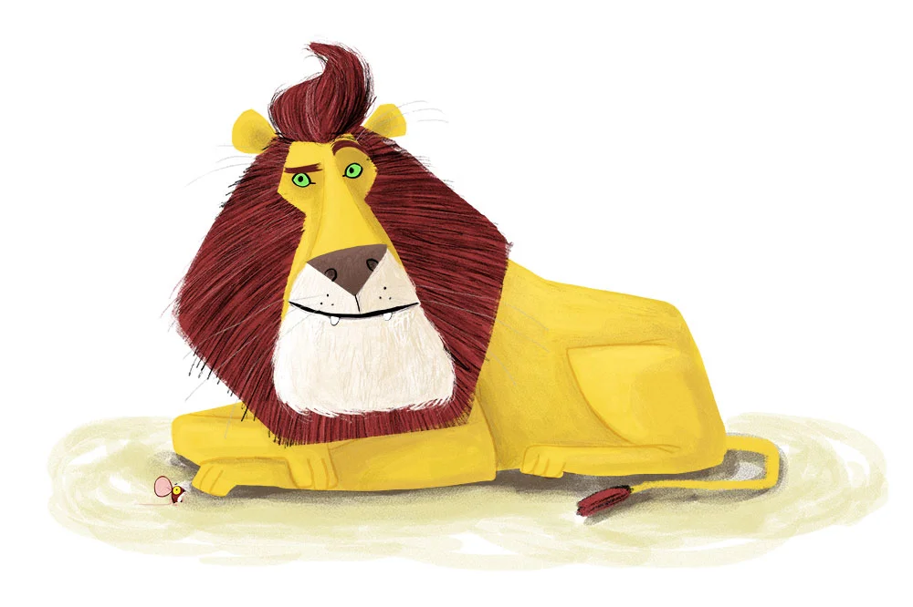
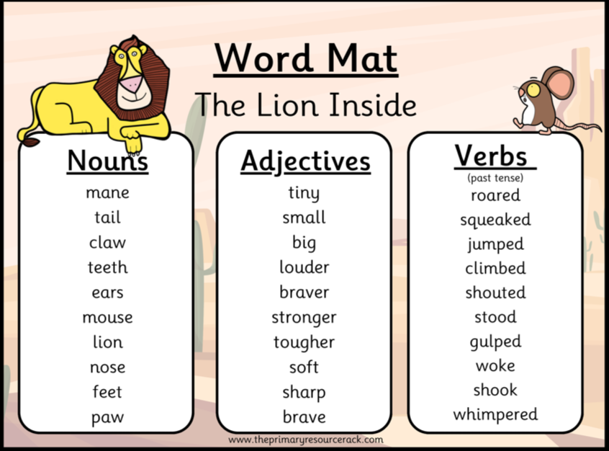
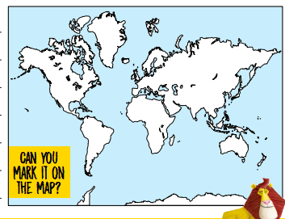
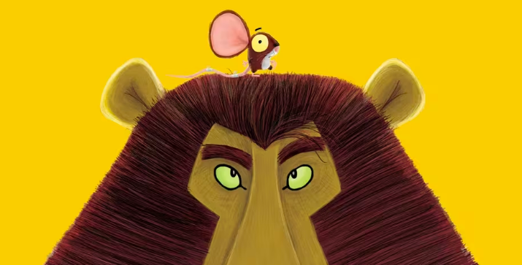
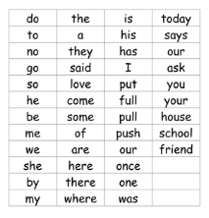
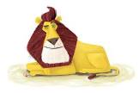
Key Vocabulary
Strong – able to do things that need lots of power
Weak – not very strong; finds things hard to lift or do
Mean – not kind; someone who says or does unkind things
Mighty – very strong and powerful
Shy – feeling nervous or quiet around other people
Alone – by yourself; no one else with you
Show-off – someone who likes to get lots of attention by showing what they can do

To improve the children’s story writing this half term, the children are going to be focusing on expanding their vocabulary by using exciting adjectives and verbs.
A reading focus
This half term, the children will focus on being able to sight-read Year 1 common exception words.
Topic overview
In this literacy topic, the children will be focusing on building their vocabulary to write an exciting short story based on the characters.

