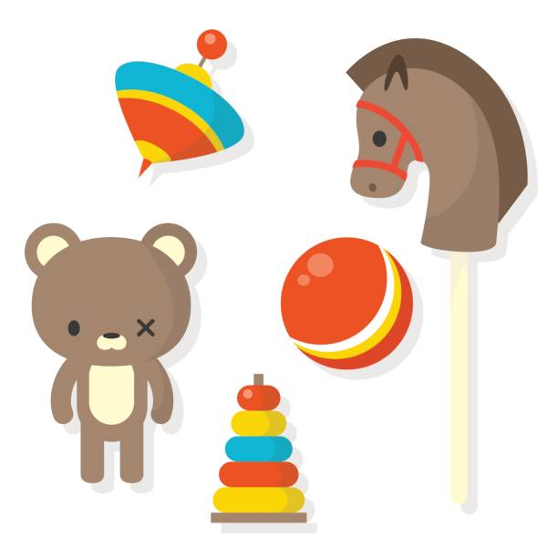
Toys Through Time
During the half term, pick and choose which activities you would like to complete as homework. You will receive 5 Diddy dots for each task completed and returned to school. All completed homework needs to be returned to school by ______________________

Draw a picture of your favourite toy and write a sentence about why you like it. | Can you create a timeline of toys from different periods? Ask a grown up for some help. | Research a famous old toy (like a yo-yo, teddy bear, or toy car) and create a fact sheet about it. | Act out a story with toys from home, imagining what would happen if your toys came to life. You can write or draw your story.
Write about what material your favourite toy is made from. | Can you design a brand new toy by drawing it, labelling it and explaining how it works? | With help from an adult, can you create a simple homemade toy (like a sock puppet, a paper kite, or a spinning top). They should bring it into school to share. | Can you create a poster or video advert for a toy from the past (e.g., a wooden train set or a spinning top)? You can highlight why it's fun and why kids would want it.
Ask an older member of the family what toys they played with when they were younger and why they liked them. | Create a "toy museum" at home by selecting 3–5 toys you have. You could display them, label them with the year you got them, and talk about why they are special. | Can you go on a “toy hunt” at home to find toys made from different materials (e.g., wood, plastic, fabric)? You could list the toys you find and say what they are made from. | Can you draw your favorite toy? Then, on the same page, imagine and draw what that toy might have looked like 100 years ago.

