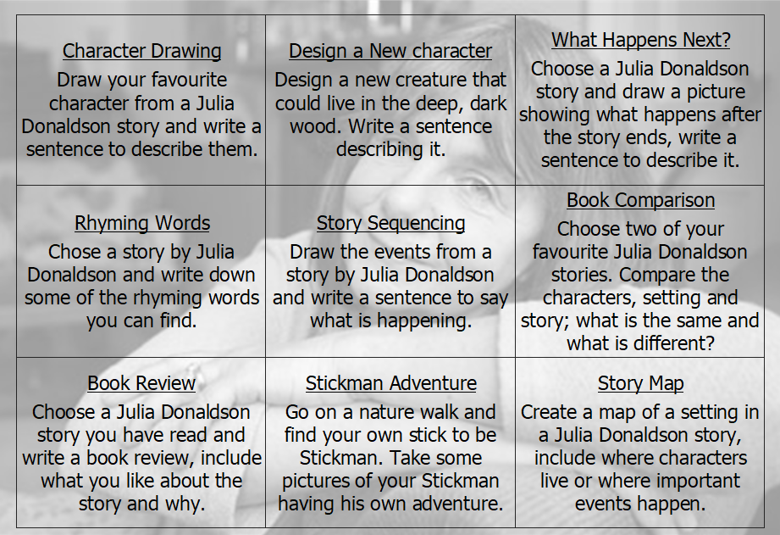



During the half term, pick and choose which activities you would like to complete as homework. You will receive 5 diddy dots for each task completed and returned to school. All completed homework needs to be returned to school by ______________

Homework Grid Summer 1