Year 1 Knowledge Organiser – Going to the seaside

• **Promenade**: A long, wide path by the sea, often with benches, where people can walk and enjoy the view.

• **Postcard**: A picture card that you can send to people from the seaside to show them what it’s like.

• **Donkeys**: Donkeys were used to give children rides on the beach in the past. It was a popular seaside activity.

• **Bandstand**: A small stage, usually found in seaside towns, where bands or musicians perform music for visitors.

• **Punch and Judy**: A traditional puppet show that has been performed at the seaside for many years, featuring the characters Punch and Judy.

• **Bathing Machines**: Small huts that people would change into their swimming clothes in before going into the sea, often used in Victorian times.

• **Pier**: A long structure that extends from the land out over the sea, often with amusement arcades, cafes, and shops.

• **Charabanc**: A type of old-fashioned bus that was used to take families and tourists to seaside resorts in the past, especially in Victorian times.

• **Steam Train**: A train powered by steam, used to travel to seaside resorts during the 19th century and early 20th century.

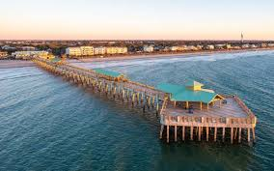

Topic overview ..

In this topic, we will explore what it’s like to visit the seaside, both today and in the past. We will learn about the fun activities people enjoy at the beach, such as swimming, building sandcastles, and riding donkeys. We will also look at how seaside holidays have changed over time, particularly focusing on the Victorian era and the early seaside resorts.

This topic will help us understand how places like piers, promenades, and Punch and Judy shows were part of the seaside experience for families in the past.

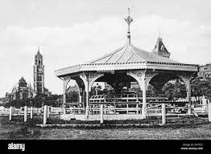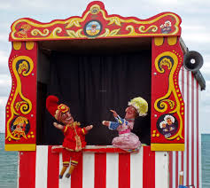

**Victorian Seaside Holidays**

* In the **Victorian era** (1837-1901), going to the seaside was a special event for families. The seaside towns were growing, and people started to visit the coast more for holidays.
* **Bathing Machines**: In Victorian times, people would use **bathing machines** to change into their swimming clothes in privacy before going into the sea. These were small wooden huts that were pulled into the sea by horses.
* **Donkey Rides**: Donkeys were very popular at the seaside in the past, giving children fun rides along the beach.
* **Charabancs**: Families would travel to the seaside in a **charabanc**, an old-fashioned bus with open sides that could carry many passenger.