BEWSEY LODGE PRIMARY SCHOOL



MENTAL HEALTH POLICY

Date of implementation | April 2026
Date of Review | April 2026

Our safeguarding mission statement.

Our mission is to ensure that all children and adults are safe from harm at all times and can thrive in an environment which is secure and free from abuse or bullying of any kind.
We work hard in creating a welcoming atmosphere, which develops the social and emotional needs of everyone; supporting, questioning, loving. At our school people are nurtured, valued and treated equally. Worries, concerns and thoughts are listened to and addressed in an environment of mutual respect.

At our school we are proud to feel:

SAFE SECURE LOVED

Policy Intent

At Bewsey Lodge Primary School, we are committed to promoting positive mental health and emotional wellbeing to all children, their families and members of staff and governors. Our open culture allows pupils’ voices to be heard, and using effective policies and procedures we ensure a safe and supportive environment for all affected, both directly and indirectly, by mental health issues.

This policy is a guide to all staff, including non-teaching and governors, outlining Bewsey Lodge Primary School’s approach to promoting mental health and emotional wellbeing. It should be read in conjunction with our safeguarding suite of policies.

At Bewsey Lodge we understand that:

Only appropriately trained professionals should attempt to make a diagnosis of a mental health problem.

Aims

- Promote positive mental health and emotional wellbeing in all staff and children.
- Increase understanding and awareness of common mental health issues.
- Enable staff to identify and respond to early warning signs of mental ill health in children.
- Enable staff to understand how and when to access support when working with young people with mental health issues.
- Provide the right support to children with mental health issues and know where to sign-post them and their parents/carers for specific support.
- Develop resilience amongst children and raise awareness of resilience building techniques.
- Instil a culture of staff and children’s welfare where everyone is aware of signs and symptoms, with effective signposting underpinned by behaviour and welfare around school.

If a member of staff is concerned about the mental health or wellbeing of a child, in the first instance they should speak to Miss Kearns, the Senior Mental Health Lead. If there is a concern that the child is high risk or in danger of immediate harm, the school’s child protection procedures should be followed and support should be sought from Mrs Bailey, the Designated Senior Lead for Safeguarding (DSL) or Mrs Price, the Deputy DSL. If the child presents a high-risk medical emergency, relevant procedures should be followed, including involving the emergency services if necessary.

Signposting

We ensure that staff, children and parents/carers are aware of the support and services available to them, and how they can access these services. Through our website, newsletters, notice boards and Facebook page, we share and display relevant information about local and national support services and events.

Teaching About Mental Health

The skills, knowledge and understanding our children need to keep themselves and others, physically and mentally healthy and safe are included as part of our PSHE/JIGSAW curriculum. Additionally, we will use such lessons to provide children who do develop difficulties, with strategies to keep themselves healthy and safe, as well as supporting children to support any of their friends who are facing challenges.

Warning Signs

Staff may become aware of warning signs which indicate a child is experiencing mental health or emotional wellbeing issues. These warning signs should always be taken seriously and staff observing any of these warning signs should alert the DSL/Deputy DSL. Possible warning signs, which all staff should be aware of include:

- Physical signs of harm that are repeated or appear non-accidental.
- Changes in eating / sleeping habits.
- Increased isolation from friends or family, becoming socially withdrawn.
- Changes in activity and mood.
- Lowering of academic achievement.
- Talking or joking about self-harm or suicide.
- Abusing drugs or alcohol.
- Expressing feelings of failure, uselessness or loss of hope.
- Changes in clothing – e.g. long sleeves in warm weather.
- Secretive behaviour.
- Avoiding PE or getting changed secretively.
- Lateness to, or absence from school.
- Repeated physical pain or nausea with no evident cause.
- An increase in lateness or absenteeism.

This list is not exhaustive

Support at School

Support is available for all children but we recognise those who are at greater risk to mental health issues. These include children who are:

- Going through difficulties such as family illness, separation, bereavement, or other stressful situations.
- Those who are in care.
- Young carers.
- Those who have had previous access to CAMHS.
- Those living with parents/carers with a mental illness.
- Those living in households experiencing domestic violence.

This list is not exhaustive

We identify any children who may need extra support through:

- Observations.
- Conversations with children/parents.
- Attendance/punctuality.
- Drop ins for parents.
- Talk Time.
- Early Help Assessments (EHA); these are completed by the DSL/Deputy DSL or Mrs Jones, EHA support.
- Multi-agency meetings.
- Worry monsters in every class.
- Mental Health Check ins in every class

We ensure timely and effective identification of children who would benefit from targeted support and ensure appropriate referral to support services by:

- Identifying children who are showing early signs of anxiety, emotional distress, or behavioural problems.
- Providing specific support/interventions for those children most at risk (or already showing signs) of social, emotional, and behavioural problems.
- Working with Children’s Services, CAMHS and other agencies services to follow protocols including assessment and referral.
- Discussing options for tackling these problems with the child and their parents/carers.
- Agreeing an Individual Care Plan/Support Plan/Individual Education Plan, if appropriate.
- Provide children with clear and consistent information about the opportunities available for them to discuss personal issues and emotional concerns.
- Provide children with opportunities to build relationships, particularly those who may find it difficult to seek support when they need it.

Support includes:

- The content of the curriculum.
- The school ethos, which promotes a positive, supportive and secure environment and gives pupils a sense of being valued.
- Ensuring that children and parents/carers know who to speak to if they have any worries.
- The school’s Positive Behaviour Policy, which is aimed at supporting vulnerable pupils in the school.
- Worry Monsters, where worries can be written or drawn.
- Mental Health Check-ins
- Daily Mindfulness
- Children’s How to Stay Safe Policy.
- Access to our Designated Provisions.
- 1:1/small groups interventions to support social, emotional and mental health needs.
- Ensuring that children know that some behaviour is unacceptable, but they are valued and are not to be blamed for any abuse, which has occurred.
- Liaising with other agencies, which support the child.
- Offering support with attendance and punctuality.
- Completing/contributing to the EHA process.
- Attending/leading multi-agency meetings.
- Talk Time sessions with the class teacher or Mr Riley.
- Sessions with our Emotional Literacy Support Assistant (ELSA) Mrs Marsh
- Sessions with our Mental Health Support practitioner – Chloe Figget

Talk Time

Talk Time is a key early intervention and should always be prioritised before considering a referral.
Follow-up interventions—such as ELSA—will not be actioned unless Talk Time sessions have first taken place, except in exceptional circumstances.

Resources to support the planning of Talk Time sessions are available on OneDrive. Class teachers/Teaching Assistants are responsible for organising and delivering these sessions; however, Mrs Marsh and Miss Kearns are available to offer guidance and support as needed.

Mental Health Support Team
Mental Health Support Team (MHST) connects schools with mental health services to support students' well-being. They train staff to identify and respond to mental health issues, help develop school policies, and provide early intervention for at-risk students. The team offers direct support during crises, ensures students and families can access mental health resources, and promotes a positive, inclusive school environment. Their goal is to improve mental health literacy, enhance support systems, and contribute to students' overall development and success. On completion of targeted support, the MHST will provide the school and parents with discharge notes and, in some cases, a care plan that will uploaded to CPOMS.

ELSA
ELSA, or Emotional Literacy Support Assistant, is a specially trained school staff member who helps children develop their emotional and social skills. Our ELSA is Mrs Marsh. She works with students to manage emotions, build self-esteem, and improve social interactions through one-on-one or small group sessions. ELSAs provide a safe space for children to talk about their feelings and learn coping strategies, aiming to create a supportive school environment that enhances students' emotional well-being and academic performance. The impact of ELSA is measured by conversations with parents, teachers and the children themselves and will be uploaded on to CPOMS.

Procedure for Referring Pupils for Mental Health Support
If Quality First Teaching and Talk Time have not resulted in sufficient improvement, teachers are advised to submit a referral for additional support. Please ensure that parental consent has been obtained prior to completing the referral.
Referral forms are available on OneDrive in the purple folder titled ‘Mental Health and Wellbeing for All’. It is essential that the form is completed with as much detail as possible so that the Senior Mental Health Lead can determine the most appropriate course of action.
Completed referral forms should be emailed to the Senior Mental Health Lead (Miss Kearns), who will then provide feedback and upload the documentation to CPOMS.
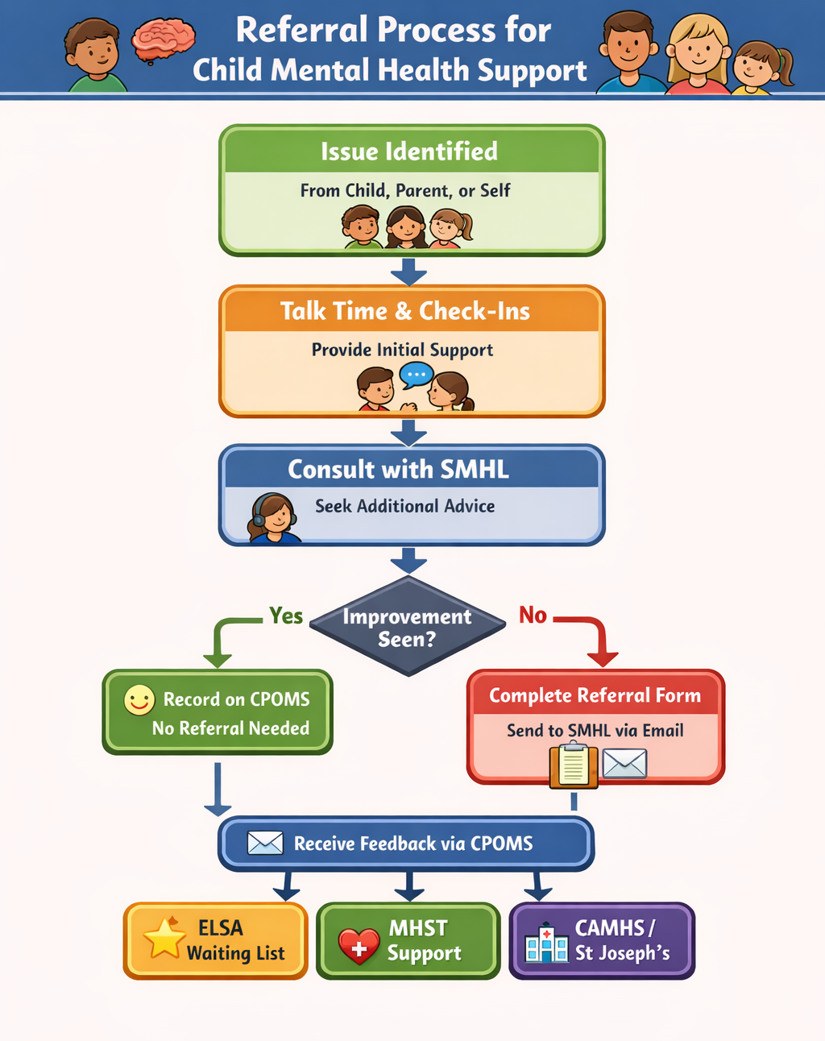

Individual Care Plans

When a child has has received a diagnosis of a mental health issue, or is receiving support either through CAMHS or another organisation, it is recommended that a Health/Care Plan should be drawn up. The development of the plan should involve the pupil, parents, and relevant professionals.

This plan should include:

- Details of the child’s situation/condition/diagnosis.
- Special requirements or strategies, and necessary precautions.
- Medication and any side effects.
- Who to contact in an emergency.
- The role of the school and specific staff.
Individual Support Plans
Individual Support Plans will be provided to class teachers following the completion of either the ELSA programme or support from the Mental Health Support Team (MHST). These documents will be similar in structure to IEPs.

Teachers must sign/read the support plan and implement the recommended strategies to ensure pupils receive appropriate and consistent support. This helps prevent pupils from returning unnecessarily to either programme in the future.

Support plans should be reviewed termly, in the same way that pupils’ IEPs are evaluated.
If a pupil already has an IEP, the relevant targets and strategies from the support plan will be incorporated into that existing document.

Managing Disclosures

If a child chooses to disclose concerns about themselves, or a friend, to any member of staff, the response will be calm, supportive and non-judgemental. All disclosures will be recorded confidentially on CPOMS and staff will follow the Tiered Approach for Supporting Mental Health (see below)
Parents would be informed if concerns are raised about a child’s mental health. If a child gives us reason to believe that they are at risk, or there are child protection issues, parents should not be informed, but the child protection procedures should be followed.

Whole school approach to working with parents/carers

We are mindful that for a parent/carer, hearing concerns about their child can be upsetting and distressing. They may therefore respond in various ways which we should be prepared for and allow time for the parent/carer to reflect and process the situation.

Signposting parents/carers to other sources of information and support can be helpful in these instances. Lines of communication will be kept open should the parents/carers have further questions or concerns.

Supporting Parents

We recognise the family plays a key role in influencing children and young people’s emotional health and wellbeing; we work in partnership with parents/carers to promote emotional health and wellbeing by:

- Ensuring all parents are aware of and have access to promoting social and emotional wellbeing and preventing mental health problems.
- Highlighting sources of information and support about common mental health issues through our communication channels (website, newsletters, notice boards, school Facebook page etc.).
- Offering support to help parents or carers to develop their parenting skills.
- Ensuring parents, carers and other family members living in disadvantaged circumstances are given the support they need to participate fully in activities to promote social and emotional wellbeing.

Supporting Peers

When a child is suffering from mental health issues, it can be a difficult time for their friends who may want to support but do not know how. To keep peers safe, we will consider on a case-by-case basis which children may need additional support. Support will be provided in one to one or group settings and will be guided by conversations by the child who is suffering and their parents/carers with whom we will discuss:

- What it is helpful for friends to know and what they should not be told.
- How friends can best support.
- Things friends should avoid doing / saying which may inadvertently cause upset.
- Warning signs that their friend needs help.

Additionally, we will want to highlight with peers:

- Where and how to access support for themselves.
- Safe sources of further information about their friend’s condition.
- Healthy ways of coping with the difficult emotions they may be feeling.

Staff Training

As a minimum, all staff will have received regular training about recognising and responding to mental health issues as part of their regular safeguarding training to enable them to keep pupils safe.

Training opportunities for staff who require more in-depth knowledge will be considered as part of our performance management process and additional CPD will be supported throughout the year where it becomes appropriate.

Staff Mental Health

We recognise that anyone can experience mental health issues for various reasons which may be out of their control. There may also be work related factors that could contribute to poor mental health such as work life imbalance, workload pressure, poor working conditions. To every extent possible, we aim to recognise and address cases of workplace pressures that contribute to mental health issues.

We aim to:

- Treat staff mental illness seriously.
- Proactively support resolution of issues causing concern.
- Support staff members who face mental health problems.
- Create pleasant workplaces.
- Encourage communication.
- Safeguarding supervisions for staff working directly with vulnerable families.

For further information, please see out Staff Well-Being Policy.


Tiered Approach for Supporting Mental Health

Urgent Care
999 call/CAMHS
Emergency parental
contact
External Support

-

SENCO/DDSL referral to external agencies such as: CAHMS, St Joseph’s, Play therapist, Parental involvement Regular review meetings such as; TAF (Team around the family) TAC (Team around the child)

Initial

Intervention
Class teacher refer to Mental Health Lead for:
- 1:1/small group work with Mr Riley
- 1:1/small group work with Mental Health Practitioner
- 1:1/small group work with ELSA
Parental involvement

Whole School Mental Health Support
Weekly Jigsaw lessons Time to Talk Restorative conversations Journals Time out cards
TA led interventions Playground PALS
School Charter
Worry Monsters

Monitoring of pupil’s day to day wellbeing via presentation in school
Parental involvement Emotion ‘check ins’

S

School to follow up with parents following
urgent medical intervention. Follow
Safeguarding and Child Protection Policy
and Procedure.
Involve Children’s Social
Care Services.

S

tytrytr
CPOMS used to record concerns and actions.
Regular liaisons with Mental Health Team and class teachers/TAs.

S

Interim measures are to be put in place and recorded on provision maps by class teacher whilst waiting lists are held. Support for these can be provided by the Mental Health Team.

Local
- Mind Works –
- Young people's CAMHS mental health drop in:
- Tuesday - Warrington Youth Cafe, New Town House, Buttermarket street, Warrington, WA1 2NH 12.00pm-1.00pm
- Tuesday - Orford Youth Base, Orford Youth Centre, Capesthorne Road, Warrington, WA2 0JF 3.30pm-5.00pm
- Wednesday - Orford Youth Base, Orford Youth Centre, Capesthorne Road, Warrington, WA2 0JF 4.00pm-5.00pm
- Wednesday - Warrington Youth Cafe, New Town House, Buttermarket street, Warrington, WA1 2NH 5.00pm-6.00pm
- Kooth - online mental wellbeing community. Free, safe and anonymous. Commissioned by the NHS.
- Youth in Mind - Drop-in service for young people aged 7-19. Opening Hours - 7 days a week 3.30pm-7.30pm.
- Merseycare Mental Health Crisis Response team - children and adolescents up to the age of 18. Access 24 hours a day and seven days a week. 01744 415 640
- Happy OK Sad (warrington.gov.uk) a website with links to information about mental health and local mental health services
- Chat Health Warrington - chathealth.nhs.uk
- ADDvanced Solutions.co.uk

National
- www.youngminds.org.uk
- Mind
- Childline
- Beat – eating disorders
- Hope again – bereavement
- Mermaid – LGBTQ+
- Rollercoaster Parent Support Group for parents on facebook

