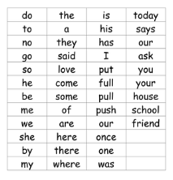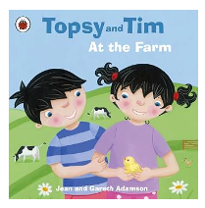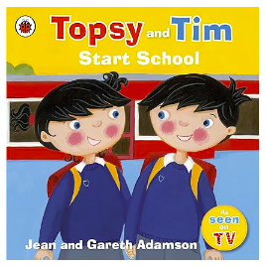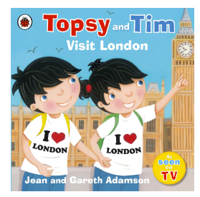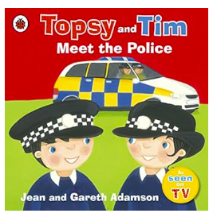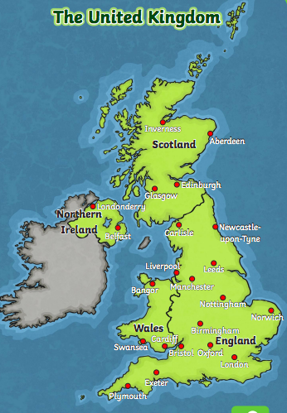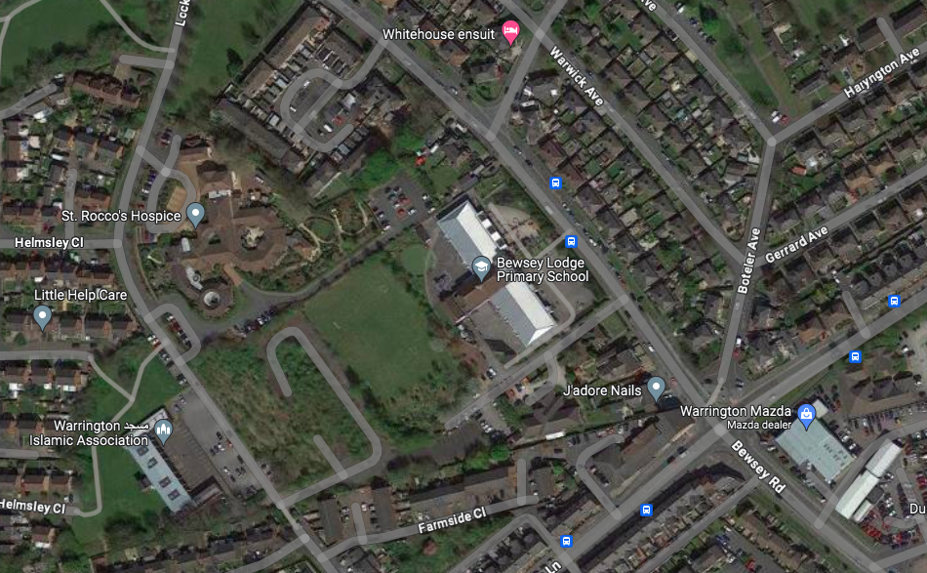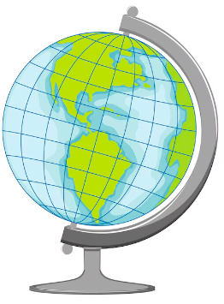

**Key Vocabulary**

* Atlas- a book containing maps.
* Physical features- Physical features like seas, mountains and rivers are natural. They would be here even if there were no people around.
* Human features-Human features are things like houses, roads and bridges. They have been built by people.
* Town- a built up area, smaller than a city but larger than a village.
* Village- a small settlement in a rural area.
* City- an urban area with lots of people living closely together.

Stories to share

A reading focus

This half term the children will focus on being able to sight-read Year 1 common expectation words.

The United Kingdom

Our local area

**Topic overview**

In this geography topic, we will be exploring where we live, our local area and people in our local community.