Learning opportunities throughout the nursery day promote learning across multiple areas of development. The information below summarises our topic based learning experiences.

Communication & Language:

* enjoy listening to longer stories & talk about them, remembering much of what happens
* begin to understand more words & use a wider vocabulary
* understand ‘why’ questions *e.g. “why do you think the caterpillar got so fat*?”
* sing a large repertoire of songs
* use talk to organise themselves & their play eg “Let’s go on a bus … you sit there … I’ll be the drier”

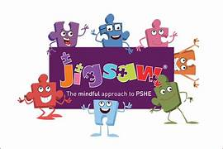

Physical Development:

* use & remember sequences of movements *music & rhythm*
* use one handed tools & equipment *e.g. making snips in paper with scissors*
* use a comfortable grip with good control *when holding pens & pencils*
* show a preference for a dominant hand
* develop self-help skills *e.g. zipping/buttoning their coat, putting on wellingtons …*

Development in this area permeates everything, specific lessons use a scheme called Jigsaw.

Personal, Social & Emotional Education:

Healthy Me

* week 1 – everybody’s body
* week 2 – we like to move it, move it
* week 3 – food, glorious food
* week 4 - sweet dreams
* week 5 – keeping clean & week 6 – safe adult

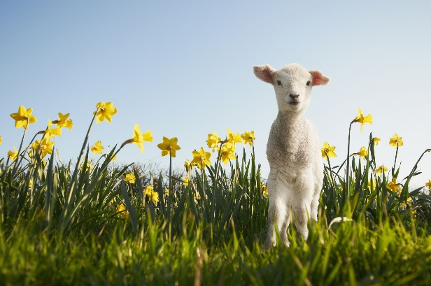

Literacy:

* develop phonological awareness:
  + spot & suggest rhymes
  + count or clap syllables in a word
  + recognise words with the same initial sound
* use some of their print & letter knowledge;
  + in early writing e.g. a shopping list, ‘m’ for mummy
  + write some or all of their name
  + write some letters accurately
* engage in extended conversations about stories, learning new vocabulary
* use some of their print & letter knowledge;

in early

Mathematics:

* recite numbers past 5
* recognise 3 objects *subitising*
* show finger numbers up to 5
* link numerals & amounts up to 5
* compare quantities *‘more than’, ‘fewer than’*
* make comparisons between objects *relating to size, length, weight & capacity*
* describe a sequence of events *‘first’ ‘then’*

Expressive Arts & Design:

* make imaginative and complex ‘small worlds’
* join different materials and explore different textures
* create closed shapes with continuous lines & begin to use these to represent things
* draw with increasing complexity & detail *spring flowers*
* explore colour & colour mixing
* listen with increased attention to sounds *including bird song*
* sing the melodic shape of familiar songs

Understanding the World:

* use senses in hands-on exploration
  + week 1 – bulbs & parts of a plant, daffodil focus
  + week 2 – outdoor learning focus, planting
  + week 3 – spring walk in forest school
  + week 4 – plant sunflowers & learn about their life cycle
  + week 5 – weather reports & charts seasonal weather
  + week 6 – forest school focus, birds, nests, feeders …
* use a wide vocabulary to talk about what is seen
* respect and care for nature