Can you name who the characters from our story One Snowy Night? | Can you count out 5 objects? | Can you name these two shapes? | Can you use the words ‘on’, ‘under’, ‘behind’ and ‘in’ to describe where your favourite teddy is.
Can you make a snowy owl using a potato masher?  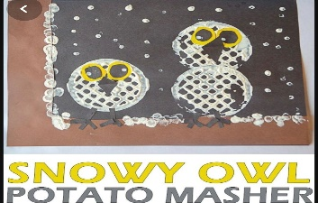 | Can you go on a winter walk? What can you see? | How many side does a triangle and a square have? | Can you make and decorate your own snowflake?
Can you share this story with your grown up? 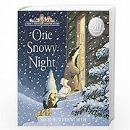 https://youtu.be/K-8AAisU1w0?feature=shared | What clothing do we need to wear in winter? | Can you make a house using a square and triangle? | Can you practice writing your own name?
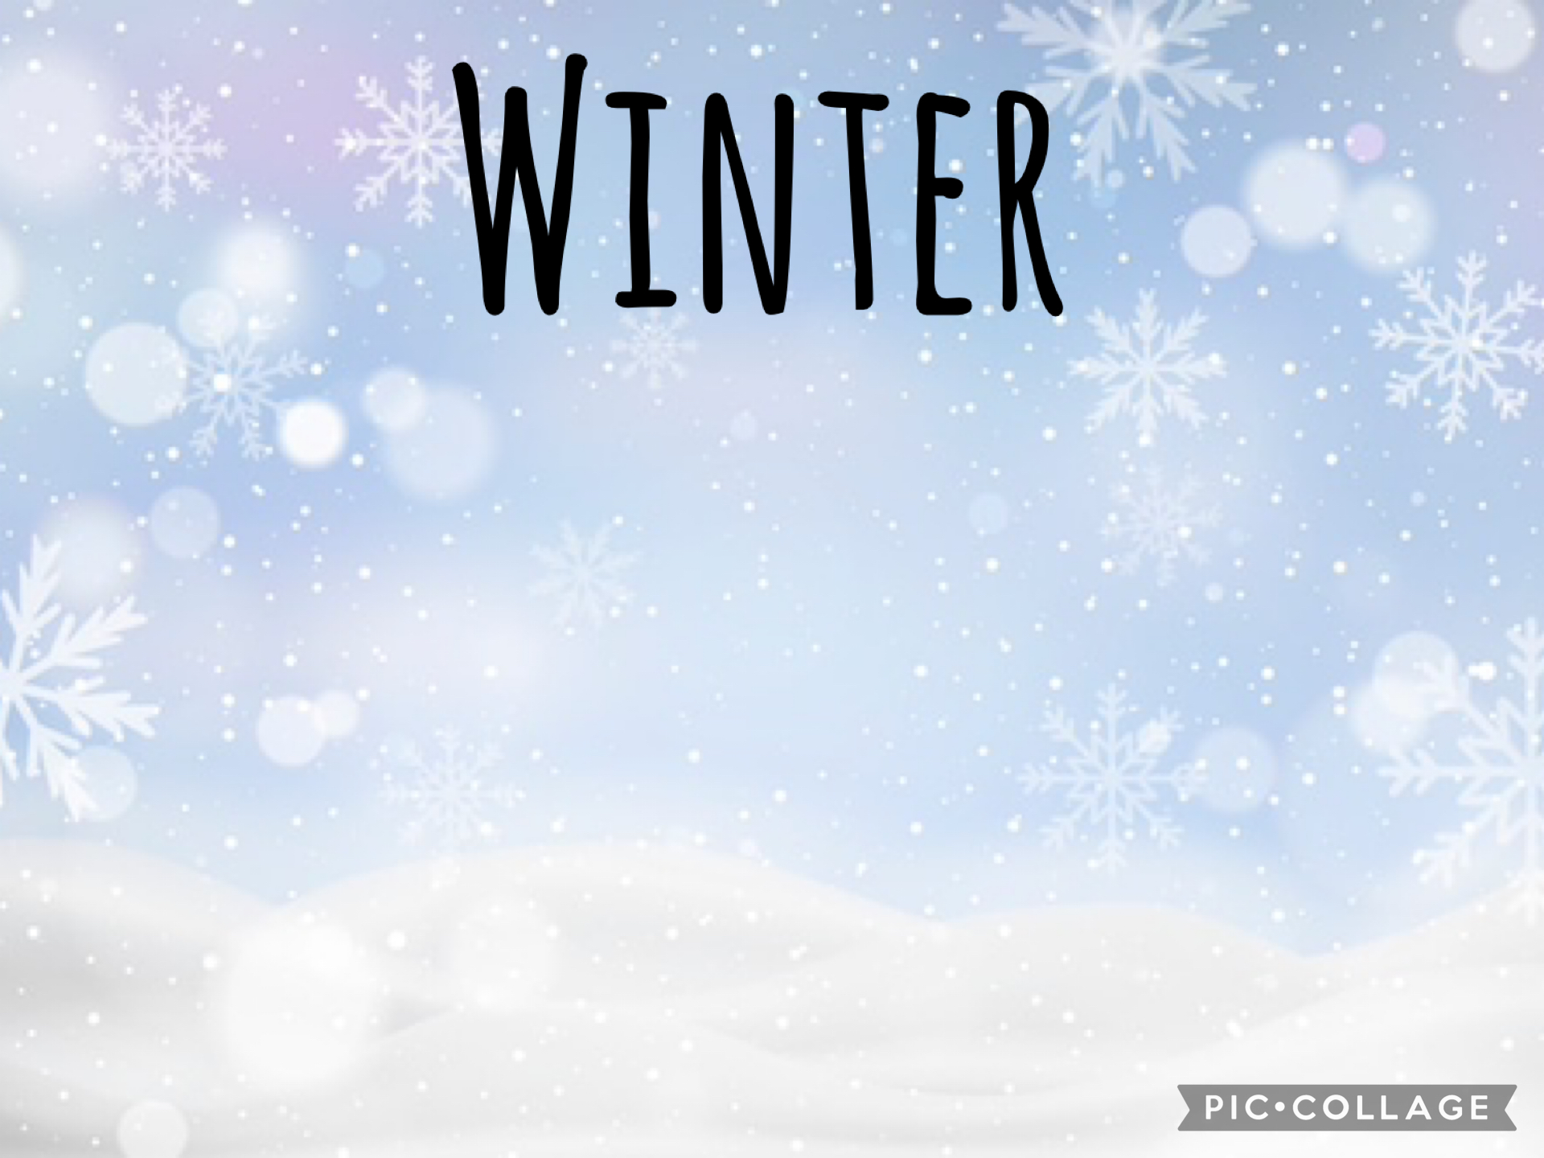
During the half term pick and choose which activities you would like to complete. You will receive a prize from the prize box for completing at least 6 of the tasks. Add you evidence to Tapestry before the last week of the half term.

