[Grab your reader’s attention with a great quote from the document or use this space to emphasize a key point. To place this text box anywhere on the page, just drag it.]
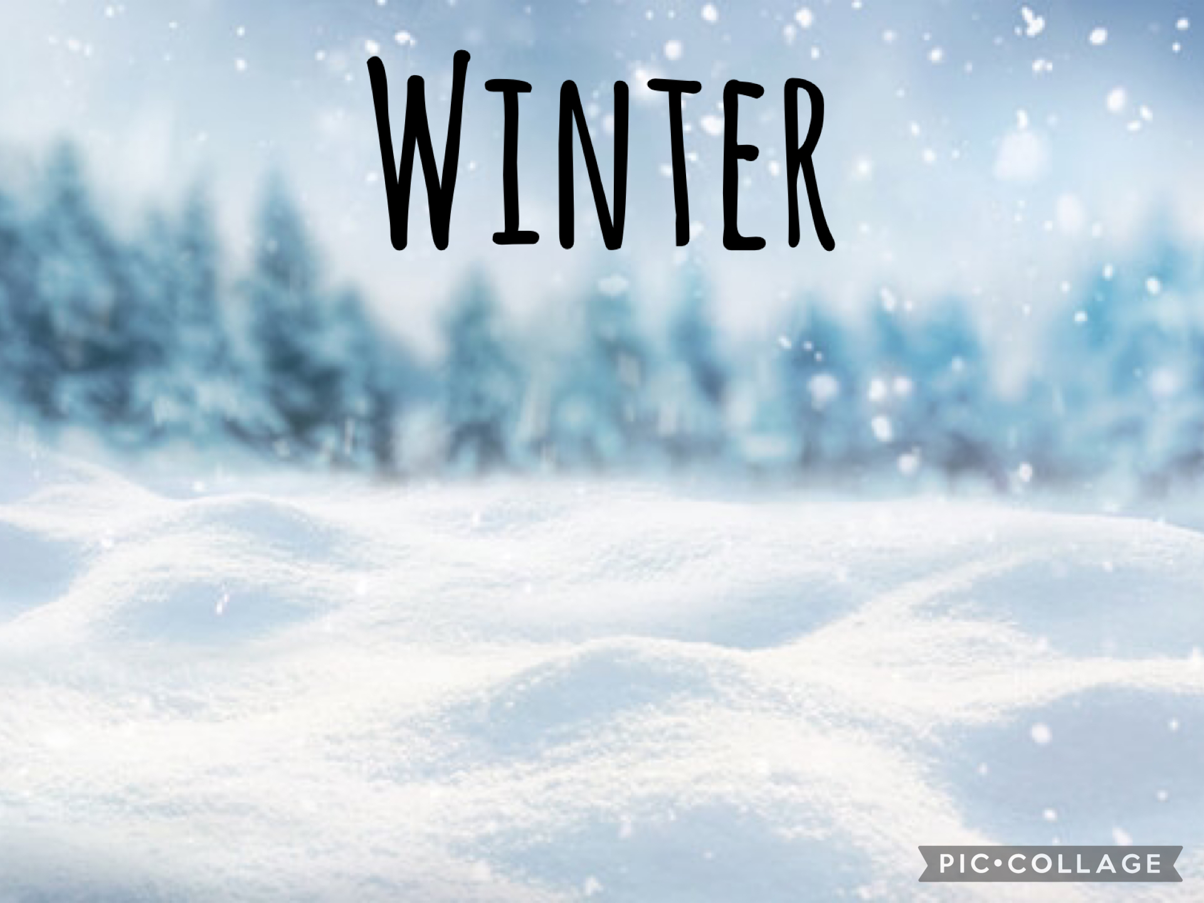 [Grab your reader’s attention with a great quote from the document or use this space to emphasize a key point. To place this text box anywhere on the page, just drag it.]
Key Vocabulary
Winter, cold, chilly, Percy, Snow, Polar Bear, Snowy Owl, Penguin, Ice, hat, gloves, Fox, Artic Fox

Can you read this story with a grown up and talk about it?
https://youtu.be/K-8AAisU1w0?feature=shared
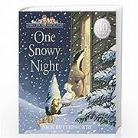
Key Text
- Percy the Park Keeper One Snowy Night
- The Winter Hedgehog
- Ten Little Penguins
What will we be taking part in:
We will be making a snowman using cotton wool?
Learning what clothing we need to wear in winter and why we need to wear them.
Singing 5 little snowflakes?
Learning about winter animals and where they live.
Going on a winter walk.
Taking part in lots of winter creative activities.

This half term we are going to be learning all about winter. We will be going on a winter walk, exploring lots of different winter animals and finding out where they live and how they live and we will be reading Percy the Park Keeper One Snowy Night.

