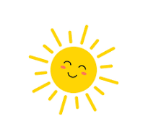
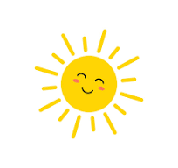Hello Spring
This half term we are going to be learning all about spring. We will be going on a spring walk, exploring all of the new baby animals, finding out where they live and how they live. We will also be reading Jasper’s Beanstalk, Growing Good and The Tiny Seed.
Books we will be reading
- Jaspers Beanstalk
- Growing Good
- The Tiny Seed
Key Vocabulary
sun, rain, seed, water, soil, plant, tall, grow, light, warm, lamb, chick, butterfly, ducks,

- Can you go on a spring walk?
- Can you find out what animals are born in spring?
- Can you practice I’m a Spring Chicken song?
- Can you find out what we need to help a seed grow?

Can you read our stories and talk about them with a grown up?
Jaspers Beanstalk, Growing Good and The Tiny Seed
https://www.youtube.com/watch?v=jemrWJX7xJo
https://www.youtube.com/watch?v=Igt_JJkcDXU
