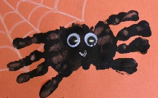  Can you make a spider using your hands and paint? | Can you make two towers and talk about if they are tall or short? | Can you go for a walk and look for signs of summer?
Can you draw a picture of the sun? | Can you read Walter’s Wonderful Web with a grown up? | Can you make your own mini beast out of junk modelling?
Can you make a pattern using objects that you find in your house? | 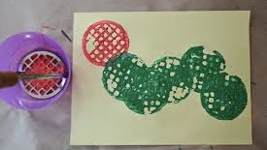Can you make a caterpillar using a potato masher? | Can you take pictures of insects that you find in your garden?
Can you find a mini beast and count their legs? | Can you hold an object in each hand and tell your grown-ups which one is heavy and which one is light? | Can you take of your beanstalk and talk about how you have looked after it?
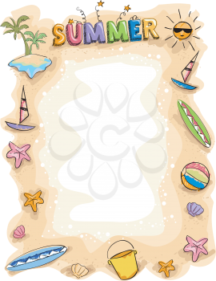
During the half term pick and choose which activities you would like to complete as homework. You will receive a certificate or prize for your efforts. Don’t forget to add pictures or videos to Tapestry before the end of the half term.

