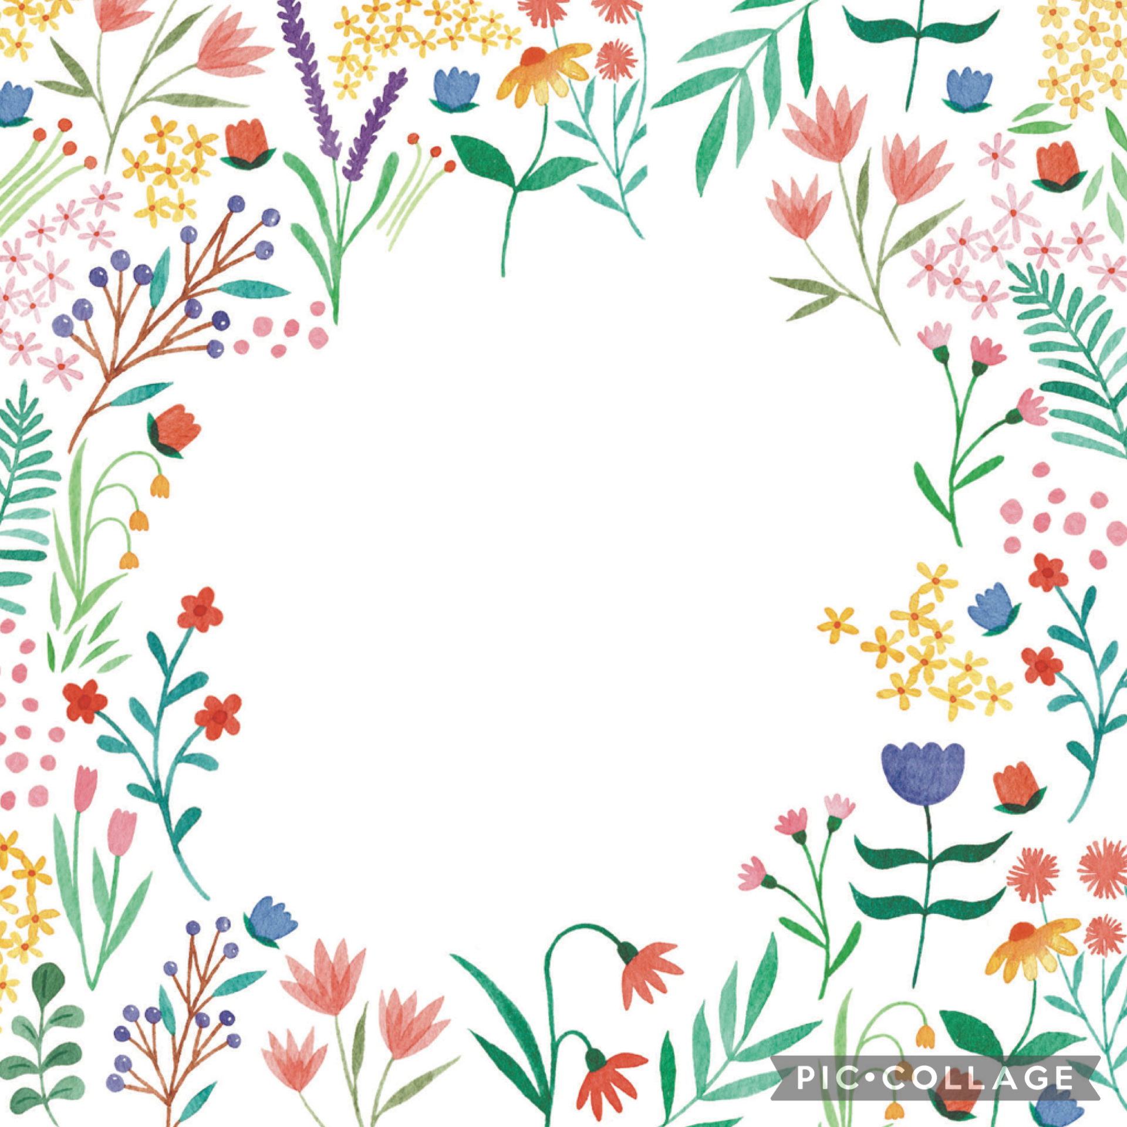Hello Summer
Our books this term are:
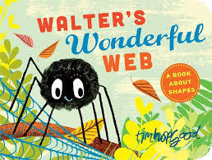 Walter’s Wonderful Web
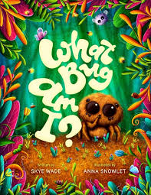 What Bug am I?
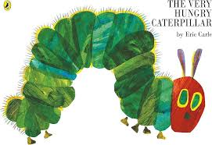 The Very Hungry Caterpiller
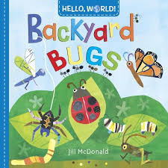 Backyard Bugs
Key Vocab:
Web, Spider, Circle, Square, Triangle, Ladybird, Wonderful, Egg, Larva, Caterpillar, Butterfly.
What we will be doing:
- Thinking about where we might find a spider’s web.
- Making our own spider’s web.
- Talking in full sentences about our web and why it is wonderful ‘My web is wonderful because……..’
- Using non-fiction text to find out information about spiders such as where they live and what they eat.
- Learning about the life cycle of a ladybird.
- Learning about all the different bugs that we might see in our gardens.
- Making our own caterpillars.
- Going on a bug hunt in Forest School.
- Making our own mini beasts using play dough.
- Observing the life cycle of a ladybird.

