
Summer
What we will be learning
Talking about our story Handa’s Surprise.
Preparing a healthy snack for our friends using the fruit in the story.
Recapping where some of food comes from.
Looking at a map to learn where Africa is in the world.
Making a woven basket just like Handa’s.
Talking about the animals in the story and where they came from.
Learning some facts about African animals.
Making some fruit scented play dough.
Moving like different animals.
Talking about our favourite animals in the story.
Our books this term are:
Handa’s Surprise https://www.youtube.com/watch?v=XyIV_xYi0as
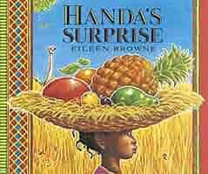
Martha Maps it Out https://www.youtube.com/watch?v=3fIeLZprZcM
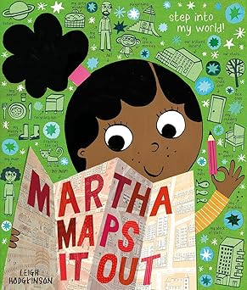
Little World on Safari
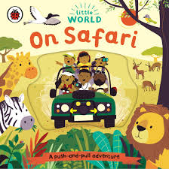

Key Vocab
Handa, fruit, basket, Africa, animals, map, monkey, zebra, giraffe, goat.

