Write a non-chronological report about a famous volcanic eruption. Remember to include sub-headings and interesting facts. | Imagine you have just survived an earthquake. Write a short story about what happened. | Write an acrostic poem for one of the following words:  - Earthquake;  - Tornado;  - Tsunami.
Create a set of quiz cards to test how smart your family and friends really are. Theme your questions around natural disasters and their effects. | Design a poster to show a volcano’s main features. Make sure you label its important parts. | Read a storybook and write why you would recommend it to a friend. What would you rate it out of 5.
Find out why people still live close to volcanoes despite the risks. Think about soil, new land, building materials, mineral deposits, hot springs and spas, electricity and tourism. Create a poster about what you have learnt. | Design and draw an earthquake-proof house.  How could you prevent the building from collapsing during an earthquake? | With a parent or carer, create a mini erupting volcano using baking soda and vinegar. Take photographs to show how you made it.  Lots of ideas on the internet about how to make this.
Create a project dictionary that explains key vocabulary related to our topic. | Write an A-Z list of adjectives (or other words) you could use to describe a volcano. | Create an advice leaflet outlining what to do should a volcano erupt.
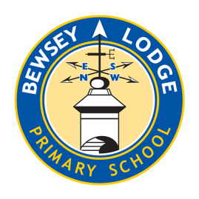

Choose your homework from the grid below:
You can choose as many tasks as you like. If you need a book or paper to record your work, just ask. You have the whole half term to choose and complete as much as you can.
Return on Monday 15th December for marking and a reward.
Opal – Is the earth violent?

