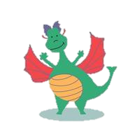

***Choose your homework from the grid below:***

You can choose as many tasks as you like. If you need a book or paper to record your work, just ask. You have the

whole half term to choose and complete as much as you can.

Return on **Monday 14th July** for marking and a reward. Try to attempt **at least one** task from the top line.

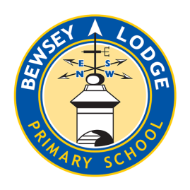

|  |  |  |
| --- | --- | --- |
| Create a fact file about a Disney character you know very well.  **Remember to use sub-headings and include interesting facts.** | Write a new adventure story for a Disney or fairy tale character.  **Remember to describe the setting and use dialogue.** | Write your own play script from an invented or favourite scene from a Disney movie.  **Remember to use stage directions and have a narrator.** |
| Create a job advert that Fiona could apply for**.**  **Remember to add details to the job description from what you know about the character.** | Draw a detailed plan of Shrek’s swamp.  **What features would it include? Remember, he does not like visitors!** | Write an alternative ending to a well-known fairy tale or Disney story**.**  **What will the characters do differently? Will this lead to the characters having a happy or sad ending? Maybe end on a cliff-hanger…** |
| Create a word search using topic words used this half term including vocabulary to describe fairy tale characters. | Design a ‘Wanted’ poster for a Disney or fairy tale villain. Include details as to why they are wanted! | Create a quiz on Disney characters e.g. are they originally a fairy tale character. How many films they have featured in? |
| Design a new everyday and ‘smart’ outfit for Shrek. What will be the differences? | Invent a new ‘Baddie’ for a Disney film. Remember to describe his appearance and personality. | Research the story of the real life Walt Disney. |

