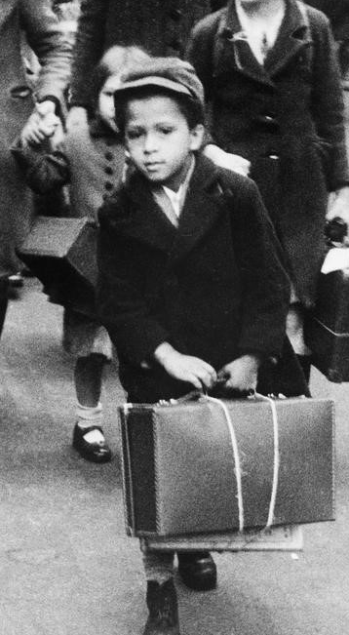

Choose your homework from the grid below:
You can choose as many tasks as you like. If you need any resources to help you with your work, just ask. You have the whole half term to choose and complete as much as you can.
Return on Monday 18th May for marking and a reward. Try to attempt at least one task.
Year 4 Opal – A Child’s War

Design a Propaganda Poster  Look at some WW2 posters, can you design your own to help with the war effort? Make it colourful and bold! | WW2 Wow Facts!  Find out 5 interesting facts about WW2 to make your classmates say Wow! | Morse Code Messaging  Can you write your name in morse code? Try and create a secret message for your friends to decode!
Rationing Diary  Everybody had to ration during the war. Write a short diary entry about the meals you ate and how you felt about rationing. | Evacuation Packing List  List 6 things you would take with you if you were evacuated from home. Don’t forget to explain why. | Outdoor Games  Research games played by children during WW2. Write down the instructions for your friend to play too.
WW2 Clothing  Draw a picture of a child during WW2. Label the different parts of the outfit, like evacuee tag and gas mask. | WW2 Map of Europe  Can you colour in and label a map of Europe during WW2? Label the countries Allied or Axis to show the countries involved. | Timeline of Events  Create a timeline of key events that happened during WW2. Use pictures to make it eye-catching. Focus on events that relate to children like evacuation.
Make an Evacuee Tag  Children who were evacuated had to wear name tags. Can you make your own evacuee tag with your name, age and address on it. Find out where you might have been evacuated to. | WW2 Wordsearch  Can you create a wordsearch with words relating to WW2? You can ask your teacher to copy it for a classroom task, to see how your classmates do. | Wartime Songs  Learn a song that was popular in WW2, such as ‘the white cliffs of Dover’. Share your song with the class and maybe teach them a few lines!
