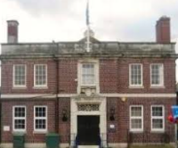

Opal – Lodge Lane to Louisiana

Choose your homework from the grid below:
You can choose as many tasks as you like. If you need a book or paper to record your work, just ask. You have the whole half term to choose and complete as much as you can.

Create a fact file about an animal in North America.  Remember to use sub-headings and include interesting facts. | Write an adventure story with characters like real life adventurers Lewis and Clark.  (Google Lewis & Clark expedition)  Remember to describe the setting and use dialogue. | Imagine you are travelling with Lewis and Clark. Write a diary about your experiences.  Remember to use your 5 senses.
Make a model of your favourite North American animal using clay, play dough or reclaimed materials. | Design a back- pack to go travelling with. What tools and food would you need on an adventure across North America? | Create a fact file on the Mississippi, maybe include a mnemonic to remember the spelling!
Create a word search using topic words used this half term including;  Climate, Mississippi, Louisiana, vegetation, culture, weather… | Create a collage of a hurricane – use a variety of textures to create it e.g. bubble wrap, sweet wrappers, newspaper, magazines. | Create a quiz on North America – 10-15 questions on topics including history, geography and popular culture.
Create your own glossary using our most important topic vocabulary  (see our knowledge organiser) | Design a travel poster, encouraging people to visit North America, include key places to visits and experiences to have. | Research how an animal from North America has adapted to their environment.
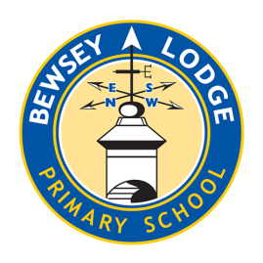
Return on Monday 10th February for marking and a reward. Try to attempt at least one task from the top line.

