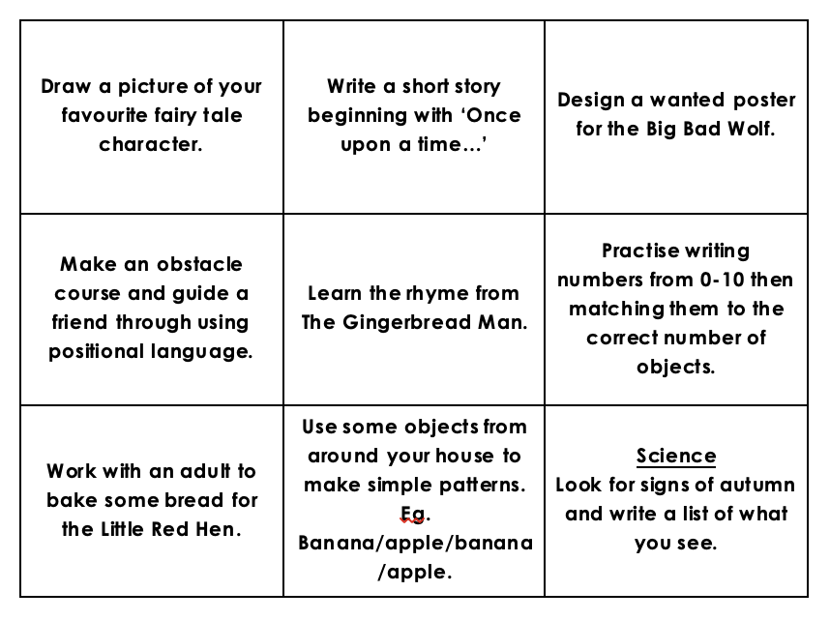

During the half term, pick and choose which activities you would like to complete as homework. You will receive a prize from the prize box for completing at least half of the tasks. Add your evidence to Tapestry before the last week of half term to win!

Traditional Tales
Autumn 2 Homework

