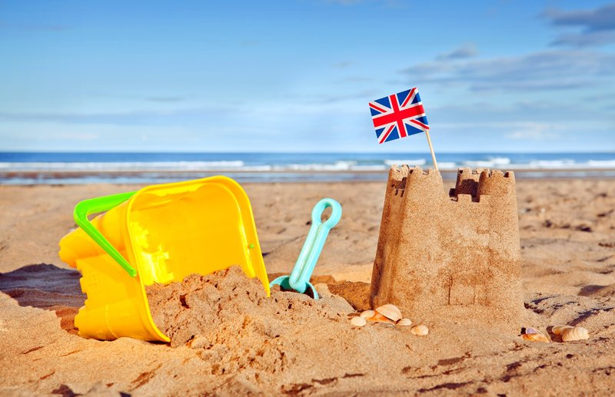
Facts we will be learning:
- Parts of a fish including: fin, scales, eyes and tail.
- How beaches have changed over time.
- What materials float and sink.
- What a map is and what it is used for.
Stories we will be sharing:
- Sharing a Shell
- Mermaid Dreams
- The Rainbow Fish
- Secret Seahorse
- The Snail and the Whale
- Barry the Fish with Fingers

Key Vocabulary we will be using:
- Front cover/ back cover
- Title
- Author
- Illustrator
- Page numbers
- Blurb
- Beginning / middle / end
- Contents page
- Index
- Heading
- Label
- Glossary

Questions we will be asking:
- Can you tell me what happened in the beginning / middle / end of the story?
- What do you think happens next?
- Where can we find information?

Non-Fiction texts we will be sharing:
- Under the Sea
- Big Ocean Creatures
- I Love Sharks
- Underwater: A First Look at Animals
- Discoveries Under the Sea
Seaside Explorers
Knowledge Organiser
Knowle
Know

