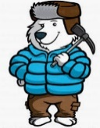
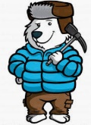
KNOWLEDGE ORGANISER
In the freezer!
Overview |  |  | The Arctic |  |  |  | Key Vocabulary  Arctic  Antarctic  North Pole  South Pole  Equator  Igloo  Climate  Inuits  Glaciers  Icebergs  Adaptation
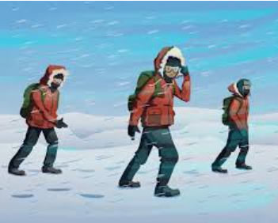  -The North Pole is the most northern point in the world. The area around the North Pole is known as the Arctic.  -The South Pole is the most southern point in the world. The area around the South Pole is known as the Antarctic.  -The polar regions (the North and South Poles) are the coldest places on Earth.  -The North and South Poles are the axis points on Earth (the Earth spins from these two points). |  |  | Terrain | 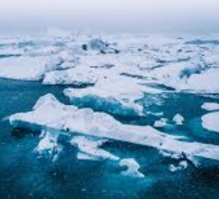 | -The Arctic Ocean is the main feature of the Arctic. However, it is covered by thick sea ice for most of the year, underneath a blanket of snow. Therefore, the Arctic is quite flat compared to the Antarctic.
 |  |  | Climate and Weather Patterns | 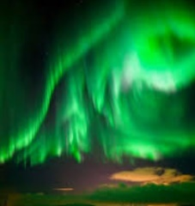 | -The Arctic is not as cold as the Antarctic: the ocean warms the air a little. It is still very cold though!  -In some months, the northern lights can be seen in the Arctic.
 |  |  | Animals | 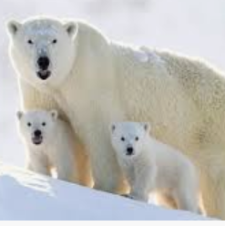 | -Polar bears are one of the apex predators in the Arctic.  -The arctic fox, reindeer, walruses, beluga whales and narwhals also live in the Arctic circle. Fact: Penguins do not live in the Arctic!
Maps
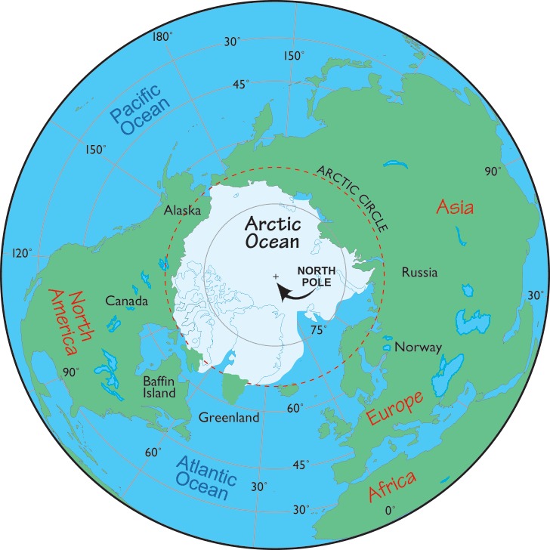
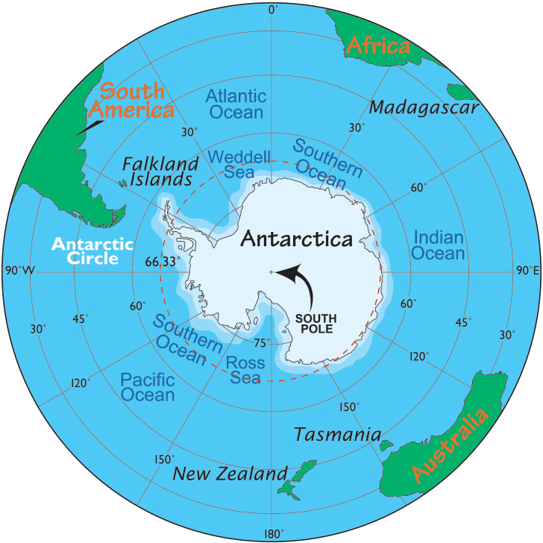
-The Antarctic lays on its own continent (Antarctica).
-The South Pole is over an ocean, not solid land.

-The Arctic is mostly an ocean that is covered in a thick layer of ice.
-The frozen ice of the North Pole is over an ocean, not solid land.

 |  |  | People and Travel
Some people live in the Arctic, such as the Inuit people. As it is very cold, people need to wear thick warm clothing, which is sometimes made from animal fur. They live in houses and can sometimes build houses called igloos using blocks of ice.

As the land is covered in snow and ice for much of the year, some people use sledges pulled by husky dogs to travel around. However, snowmobiles are being used more nowadays as they can be faster.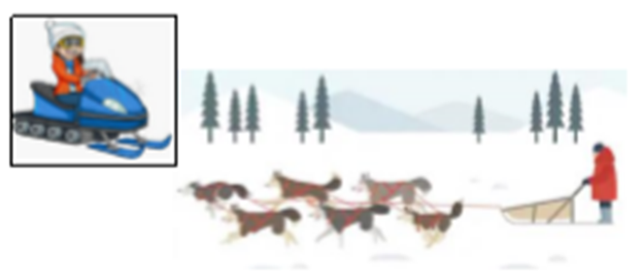
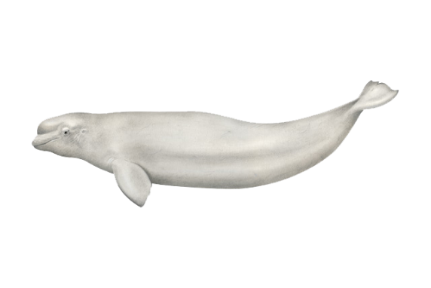
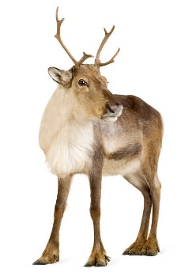
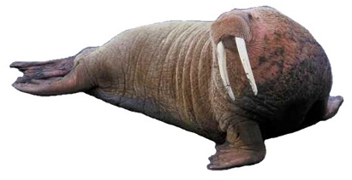
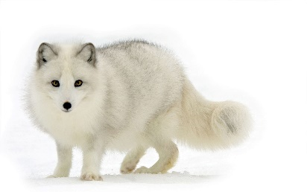
There are lots of animals in the Polar Regions. You might wonder how they survive, but they are adapted to their surroundings. Some have very thick fur so they don’t get cold. Many of them have a layer of blubber underneath their fur to keep them warm too. Some of the animals are also white in colour so that they are camouflaged against the snow.

