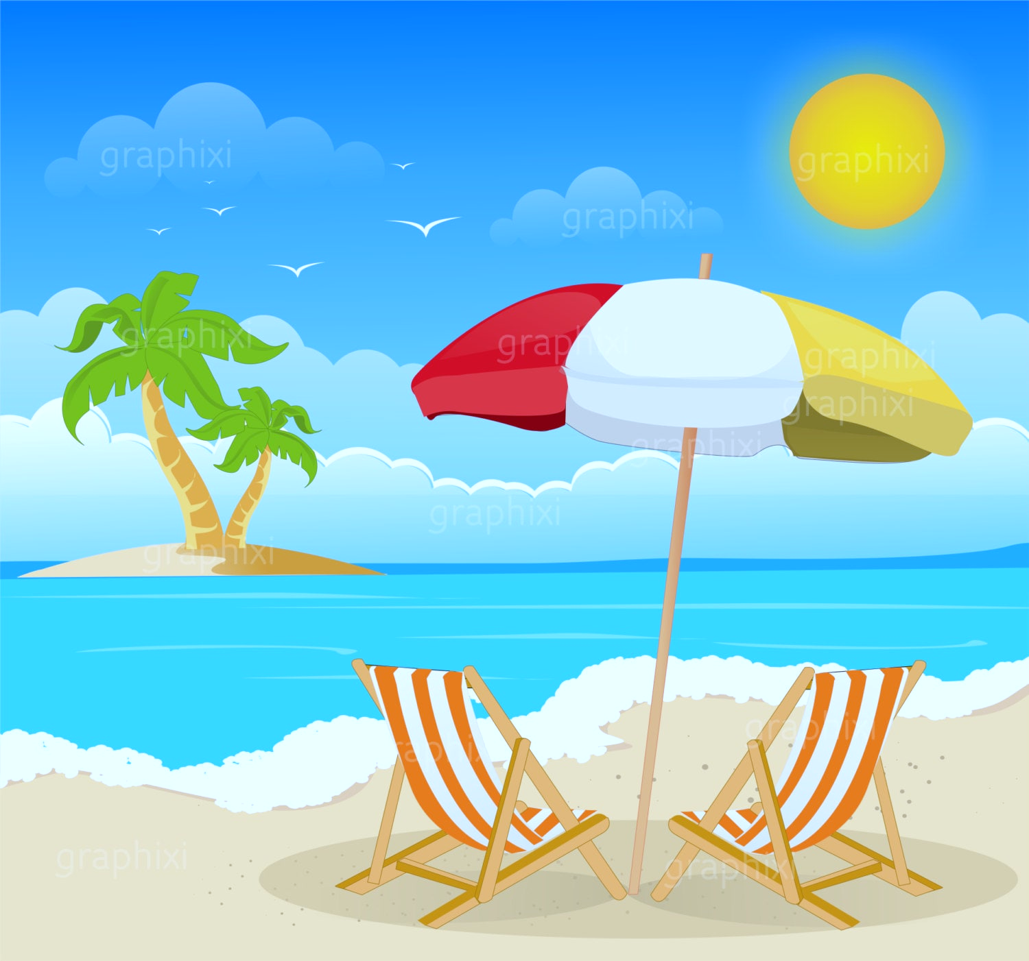
Year 1 Homework for Summer 2
What?
You can choose as many tasks as you like. Don’t forget to take pictures, too!
When?
You have over the whole half term to complete. Return for week beginning Monday 14th July for marking and a reward!

Shell Counting  Task: Count how many shells, crabs or starfish are in a seaside picture. | Seaside Shop  Task: Set up a pretend seaside shop. Use real or play money to “buy” ice creams, buckets, and spades. | Seaside Animal Fact File  Task: Choose one seaside animal (e.g., seagull, crab, starfish) and draw it. Write 1–2 facts about it. | What to Pack for the Beach?  Task: Draw and label things you would take to the seaside.
Sandcastle Drawing or Model  Task: Draw or make a sandcastle using junk modelling or playdough. | Seaside in a Shoebox  Task: Create a mini beach scene in a shoebox using materials from home. | Seaside Walk or Virtual Visit  Task: Visit a beach or explore one virtually (using videos). Draw your favourite thing you saw and write a sentence about it. | Seaside Word Hunt  Task: Find and write seaside-themed words that use phonics sounds.
Label the Picture  Task: Label parts of a seaside scene (sun, sea, sand, boat, fish, towel). | Ocean Sounds Drawing  Task: Listen to seaside sounds (waves, seagulls, splashing). Draw what you imagine. | Create a Seaside Puppet Show  Task: Make puppets (fish, lifeguard, crab, surfer) from paper or socks. Create a short performance. | Seaside Now and Then  Task: Look at old photos (or use printed ones) of beaches from the past and today.  Compare: “What has changed? What is the same?”

