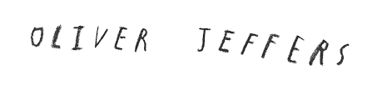
During the half term pick and choose which activities you would like to complete as homework. You will receive up to 5 didi-dots for each task completed and returned to school by Monday 20th May.

To get you started with Oliver Jeffers, read and talk about the story “Happy Easter from the Crayons” with your grown up. | The Crayons decorate an Easter Egg. Can you decorate an Easter Egg using symmetrical patterns? | Write down the names of the shapes that the Crayons create. Make a table to show how many sides and vertices each one has. | The Crayons make an Easter basket. Can you weave an Easter basket too?
Go to the library and read Oliver Jeffers books. Keep a diary of the books you read. | Make your own wordsearch with characters from Oliver Jeffers story. | Make a diorama of your favourite setting from an Oliver Jeffers story. | Look closely at some pictures Oliver Jeffers has created. Can you draw your own illustrations?
Write your own story using characters from one of the books. | Find out all about Oliver Jeffers and write a fact file about him. | Write an acrostic poem, using the word “STORY”. | Make a stick puppet of your favourite Oliver Jeffers character.

