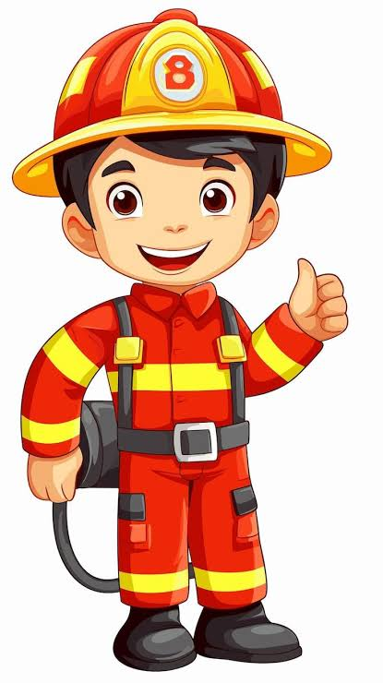
London's Burning!

Would the Great Fire Have
Happened Today?

During the half term, pick and choose which activities you would like to complete as homework. You will receive 5 Diddy Dots for each task completed and returned to school.
Find out 5 facts about the Great Fire of London. | Research Samuel Pepys. Write 5 sentences explaining why he is important. | Draw or paint a picture of the Great Fire of London. | Create a timeline showing the key events of the fire.
Build a house like one from 1666. | Write a diary entry as a child living through the fire. | Find 5 facts about firefighters today. | Design a modern fire engine and label it.
Make a fire safety poster. | Bake London-themed biscuits and bring a photo. | Create a map showing where the fire started. | Research why the fire spread so quickly.
Imagine the fire happened today. What would be different? | Write a poem about London or fire. | Compare London in 1666 and London today. | Interview a family member about fire safety.

All completed homework needs to be returned to school by Monday 14th December.

