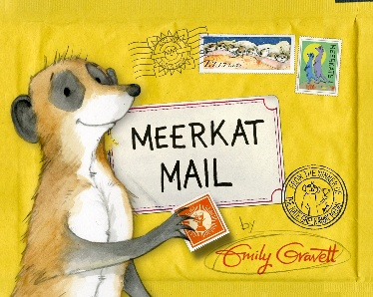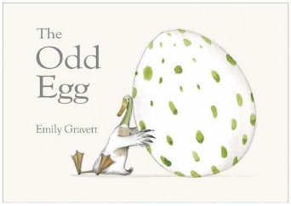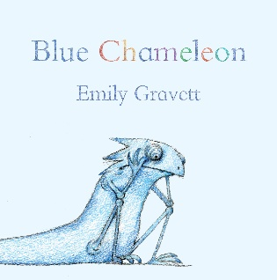

**Knowledge Organiser**

**Mrs Hopson & Miss Kearns**

**Summer Two**

**Emily Gravett**

**Time Adverbials**

The next day As soon as

Later on After a while

yesterday today

tomorrow All of a sudden

Eventually Later that night

Afterwards later

Immediately after that

**Facts about Emily Gravett**

1. Emily was born in 1972 in Brighton, England.
2. Her first book was published in 2005. It was called “Wolves”.
3. As well as writing books, she also illustrates them.
4. For eight years, she travelled around the UK in a big, green bus!
5. Emily has won lots of awards for her writing and illustrations.

Emily Gravett has lots of animal characters in her books. Find out what you can about these animals from her books:

**Badgers, Squirrels, Chameleons**

**What makes a good book?**

**Book Vocabulary**

**Author** - a writer of a book, article, or document.

**Illustrator** - provide (a book, newspaper, etc.) with pictures.

**Cover** - A book cover is any protective covering used to bind together the pages of a book.

**Blurb** - a short description of a book, film, or other product written for promotional purposes.

**Fiction**- literature in the form of prose that describes imaginary events and people.