Read lots of books with wolf characters. Keep a diary of the books you read. | Listen to the music “Peter and the Wolf” by Prokofiev. Write about what you think of the music. | Look closely at some pictures of wolves. Make a collage of a wolf. | Find out where wolves live in the world. Locate the countries on a world map.
Write a book review of your favourite wolf story book. | Each character is represented by an instrument in “Peter and the wolf”. Which is your favourite and why? | Which family of animals do wolves belong to? Write a fact file about another animal that is part of this family. | Wild wolves became extinct in this country. Can you find out why and write a report about it?
Write your own story that has a wolf as the main character. | Research the instrument from above and write some facts about it. | Write an acrostic poem, using the word “wolf” or “wolves”. | Make a wolf mask – will your wolf be a villain or not?
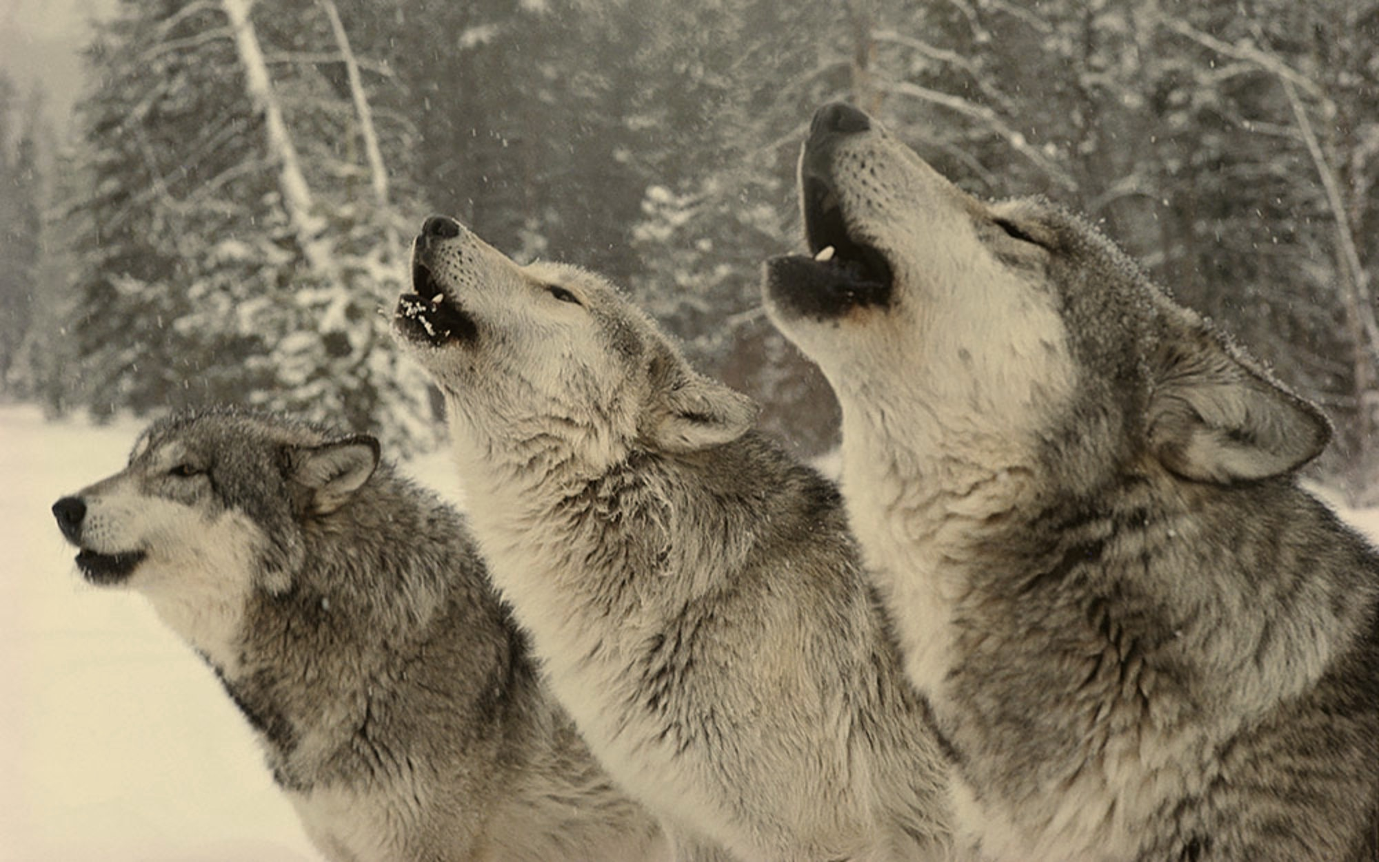
During the half term pick and choose which activities you would like to complete as homework. You will receive up to 5 didi-dots for each task completed and returned to school by Monday 30th March.

Is the wolf always a villain?

