Facts about wolves
- Wolves have fur made of two layers.
- They live in groups called packs.
- Young wolves are called pups.
- Female wolves usually give birth to five or six wolves in a litter.
- Wolves howl to communicate with each other.

Topic overview
In this English topic, we will be considering the question, is the wolf always a villain? We will be reading a variety of traditional tales and finding out about real life wolves.

Where are wolves found in the world?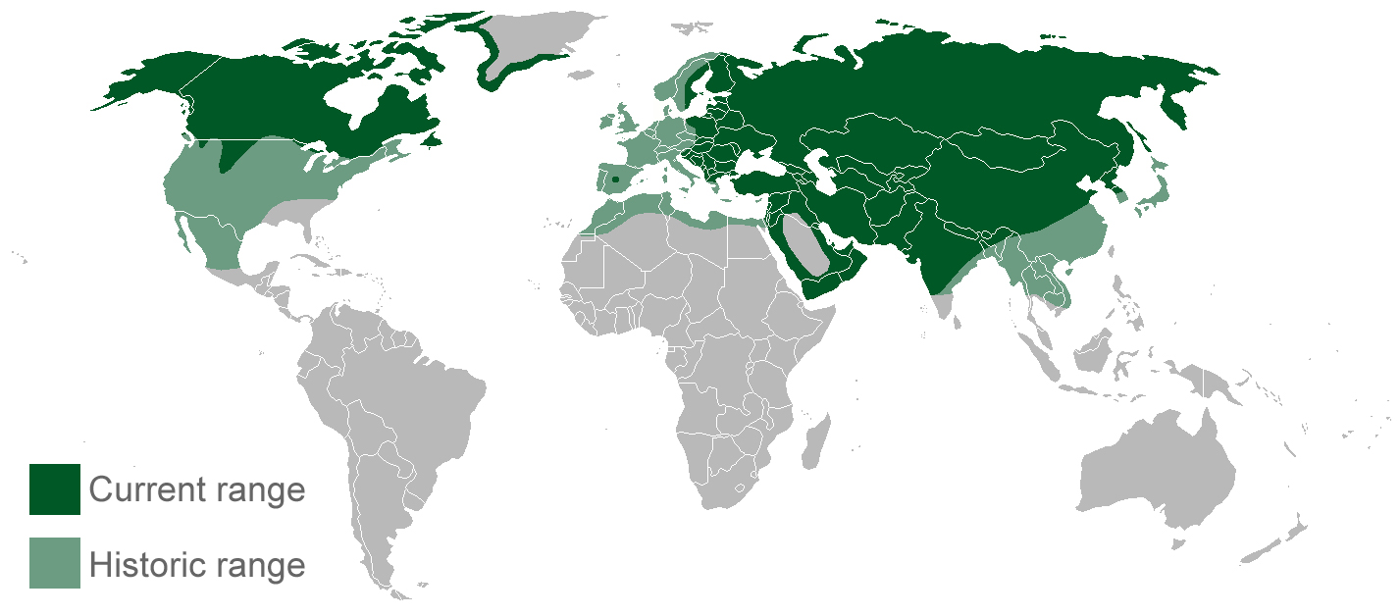

Features of a traditional tale
- Talking animals as some of the main characters.
- Character’s names tell you about their character e.g. big, little, red.
- Countryside or forest setting.
- Often a repeated phrase throughout the story.
- Lesson learnt at the end of the story.
- Happy ending for the main character.

Key vocabulary for stories
Setting- the setting is where a story takes place, this is usually described at the start of the story
Character- There will usually be lots of characters in a story, some good, some bad. The characters might be humans or animals.
Problem- the problem is when something happens in the story that needs to be solved, usually by the main character
Resolution- the resolution is the way that problem is solved in the story
Description- when there is more information about the characters or the setting in the story using adjectives

Adverbs
quietly closely happily
gracefully cheerfully
sadly angrily hungrily
far above outside behind
later yesterday after that
Parts of a wolf
