|  |  |  |  |
| --- | --- | --- | --- |
| **Write a list of all the flowers you can find in the garden. Take photos as you go.** | **Make a flower or plant using 3D shapes in your recycling.** | **Image a giant beanstalk growing in your garden… what would you like to find up there? Draw a picture and write about it.** | **Sunflower is a very long word for a very tall flower. What other flowers or plants can you find starting with the ‘s’ sound?** |
| **There are 10 seeds waiting to grow in a flower pot.**  **If 4 seeds start to grow, how many seeds will still be waiting to grow? Can you draw a picture to show your answer?** | **Plant some seeds at home. What did you need to help you? Write a shopping list.** | **Draw or paint a flower. What colours will you need? Can you label it?** | **Can you collage a flower using different things found in your house?** |
| **Visit a garden centre and find out a plant fact.** | **When you visit the supermarket, have a look at all the different shapes, sizes and colours of beans (some might be in tins). Can you count them all?** | **Make a weather chart and record the weather in your garden for a week.** | **Jack’s beanstalk was very tall. Can you find 5 things in your house that are taller than you and 5 things that are shorter than you?** |

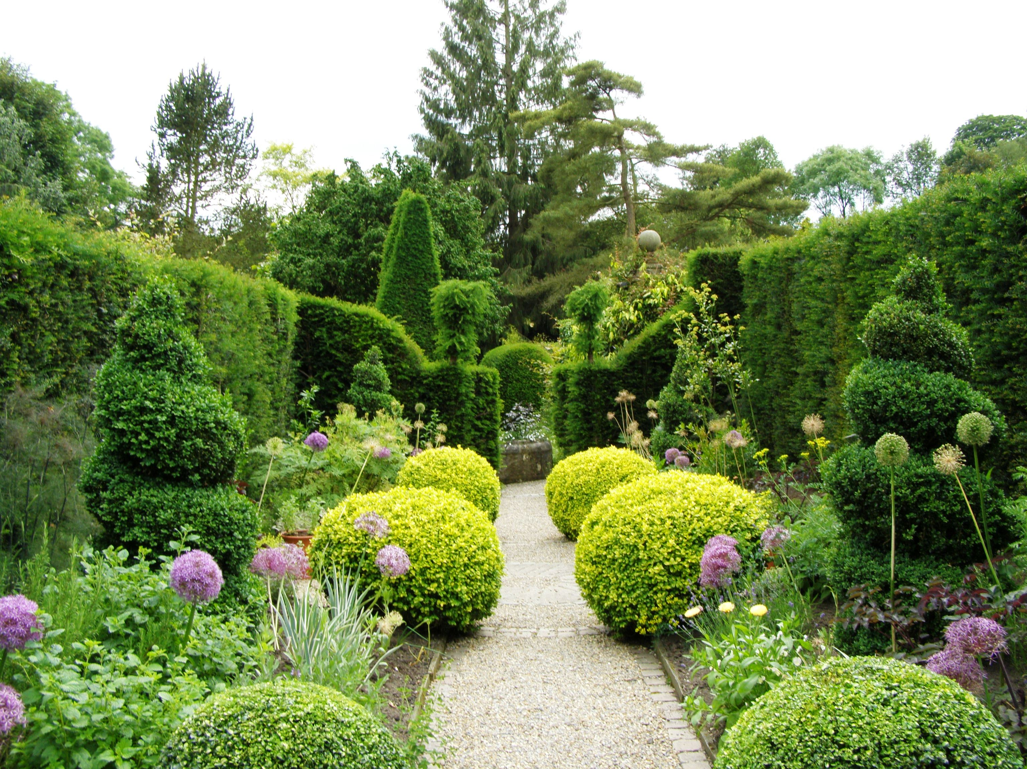

During the half term pick and choose which activities you would like to complete as homework. You will receive a certificate for your efforts. Don’t forget to add pictures or videos to Tapestry.

Please complete and send in your activities by Monday 25th March 2024.

Let it Grow!