Draw and label a winged minibeasts. | Practise reading and writing your High Frequency Words. | Have a look in your garden. Can you list the places you find minibeasts living? | Collect resources we can use to fill our bug hotel.
List as many different things with wings as you can think of. | Go on a minibeasts hunt. | Write 3 or 4 sentences about a’ thing with wings’ of your choice. | Practise recognising and writing numbers from 0-20.
Practising finding one more and one less than a given number. | Learn a song or rhyme about a winged minibeasts. | Ask an adult to help you to find out about the life cycle of a butterfly. | Make a spring collage of animals and plants your likely to see.
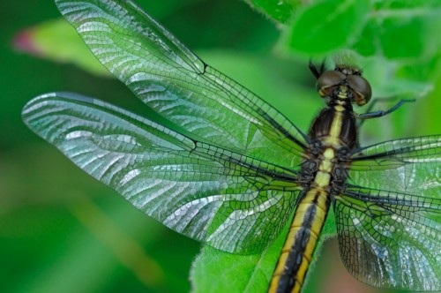
During the half term, pick and choose which activities you would like to complete as homework. You will receive a certificate or prize for your efforts. Don’t forget to add pictures or videos to Tapestry by Monday 20th May 2024.
Things with Wings

