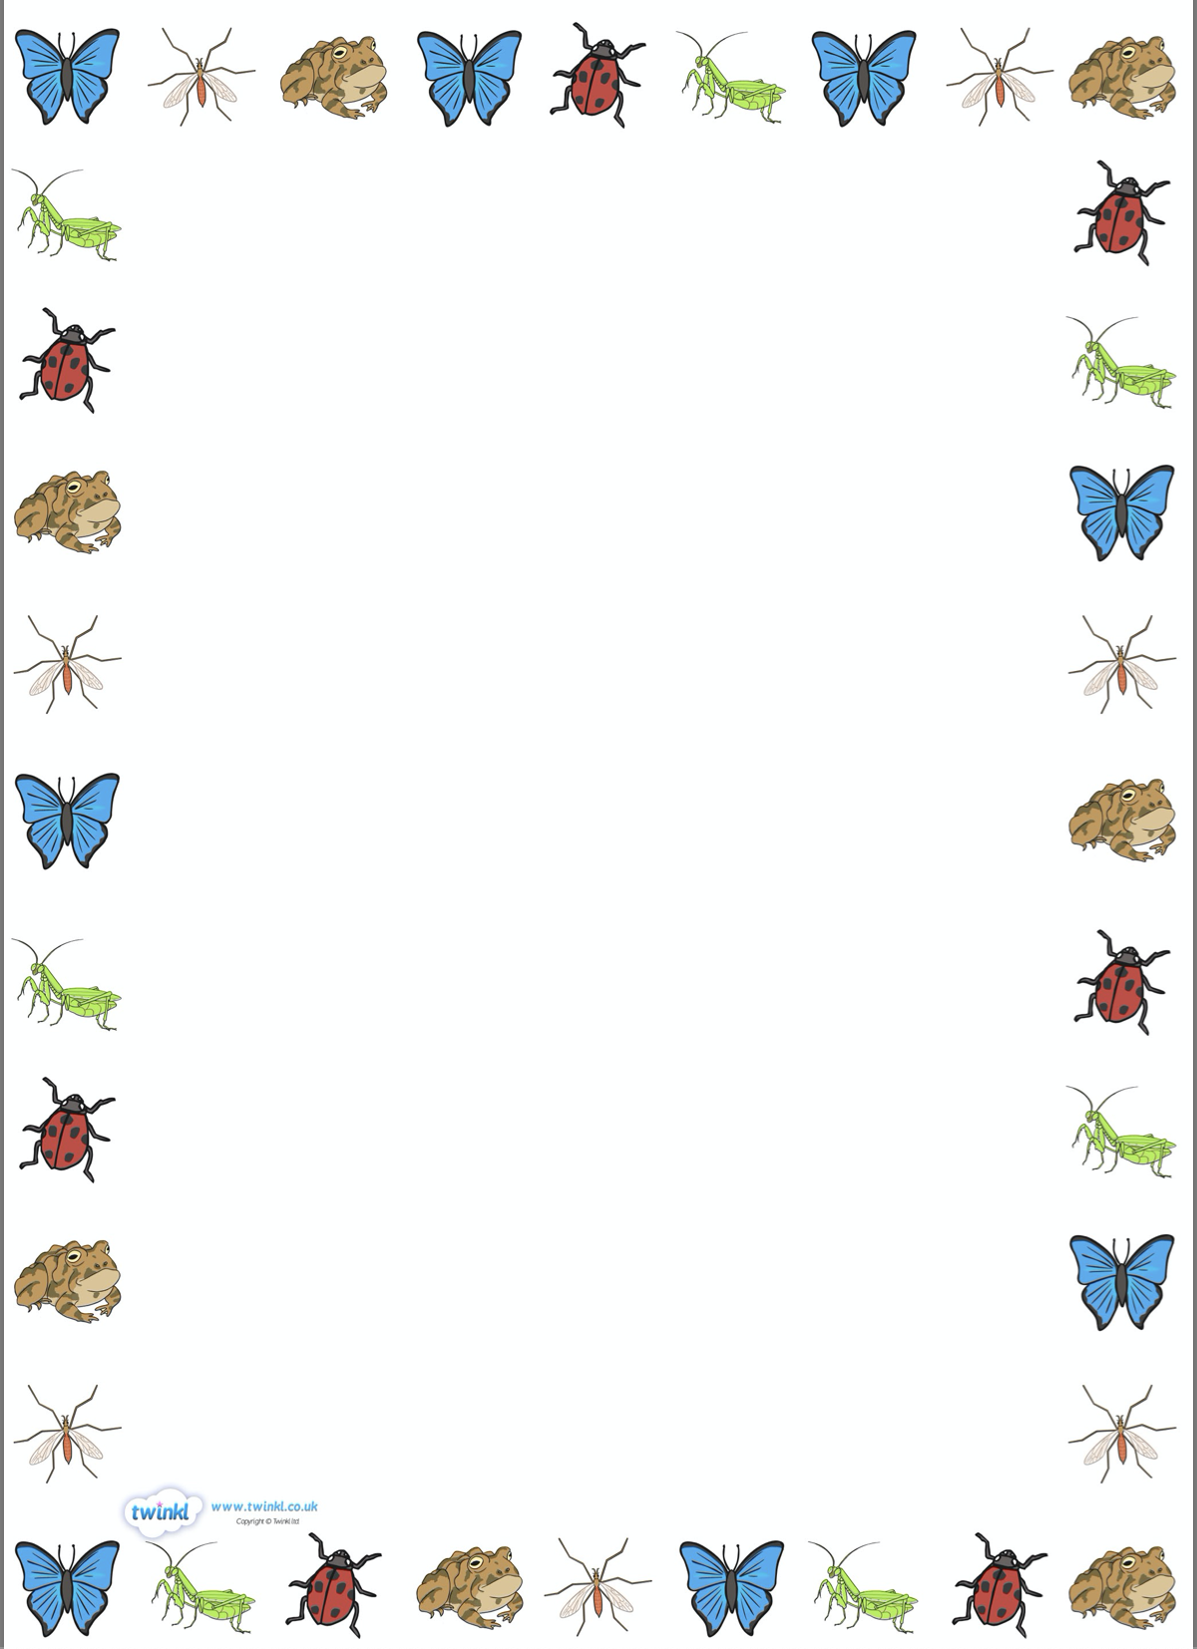

Questions we will be asking:

* What are minibeasts?
* Where do minibeasts live?
* What do they eat?
* How big are minibeasts?
* How do they move?

Stories we will be sharing:

* Superworm.
* Yucky Worms.
* Aaaarrgghh! Spider!
* Mad About Minibeasts.
* What the Ladybird Heard.
* Incy Wincy Spider.
* The Very Busy Spider.
* Christopher’s Caterpillars.

Key Vocabulary we will be using:

* Minibeasts
* Habitat
* Life cycle
* Insect
* Chrysalis
* Antenna
* Chick
* Hatching

Facts we will be learning about:

* We usually see minibeasts in the spring and summer months.
* How minibeasts move and grow.
* What they eat, what they look like and where they live.
* The different stages in the lifecycles of a chicken.

Non-fiction texts we will be sharing:

* Bugs
* Minibeasts under a stone
* A World of Minibeasts
* Wiggling Worms at Work

What we will be doing:

* Making wormeries.
* Observing the life cycle of a butterfly.
* Observing the life cycle of a chicken.
* Building our own bug hotel.
* Designing a garden for minibeasts.

Things with Wings

Knowledge Organiser