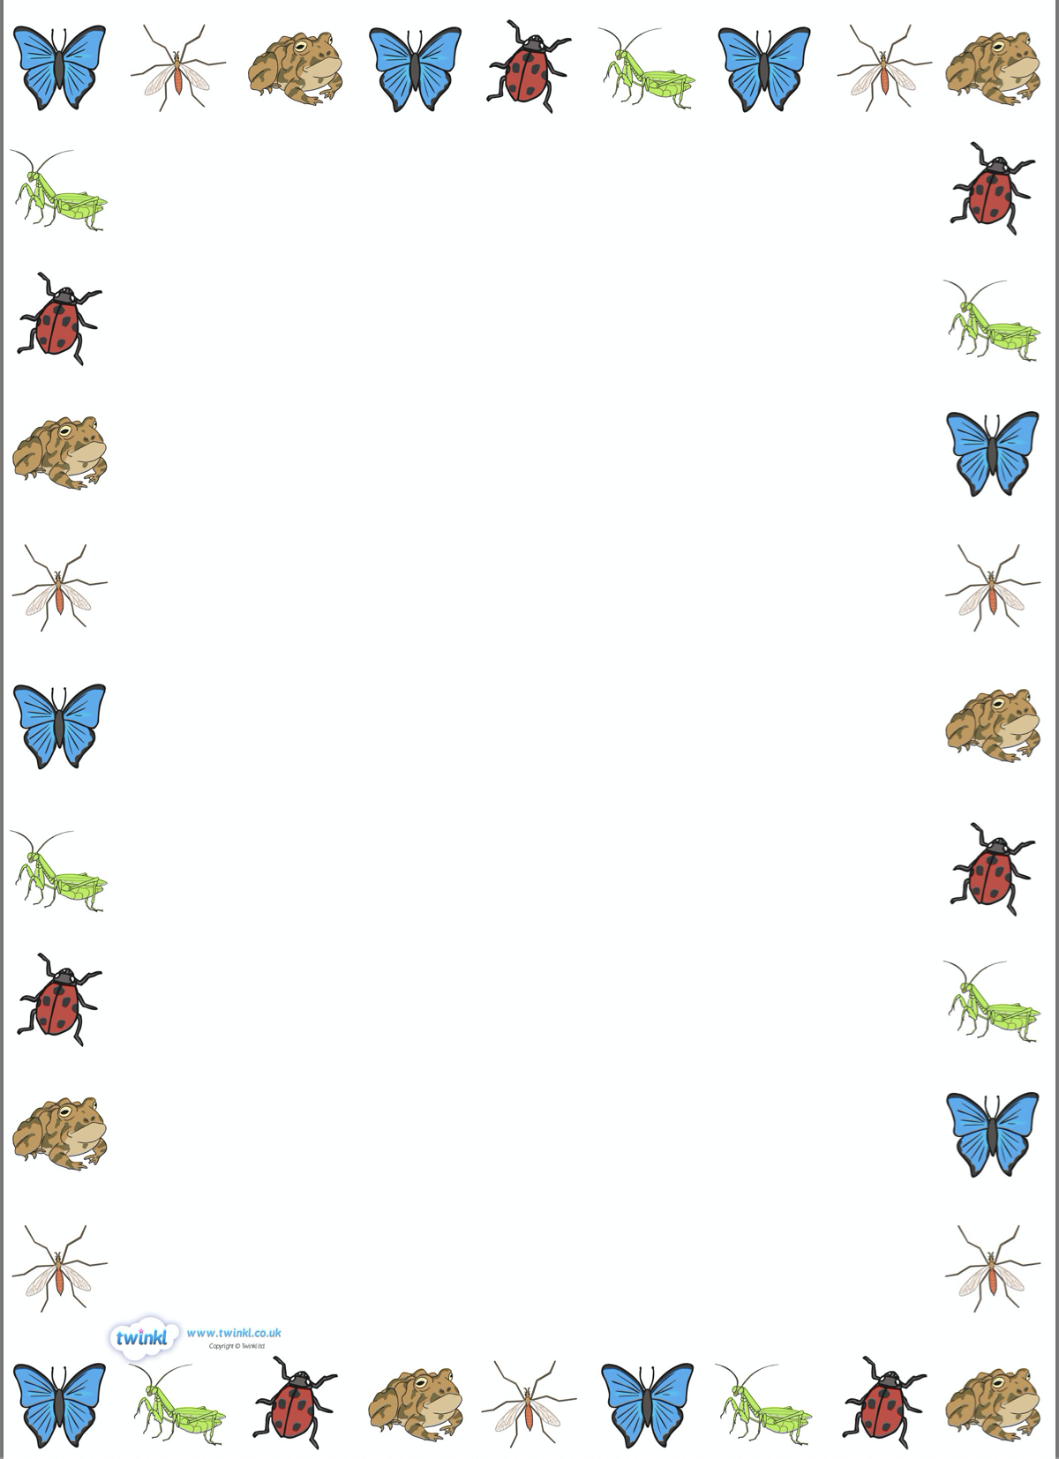
Questions we will be asking:
- What are minibeasts?
- Where do minibeasts live?
- What do they eat?
- How big are minibeasts?
- How do they move?
Stories we will be sharing:
- Superworm.
- Yucky Worms.
- Aaaarrgghh! Spider!
- Mad About Minibeasts.
- What the Ladybird Heard.
- Incy Wincy Spider.
- The Very Busy Spider.
- Christopher’s Caterpillars

Key Vocabulary we will be using:
- Minibeasts
- Habitat
- Life cycle
- Insect
- Chrysalis
- Antenna

Facts we will be learning about:
- We usually see minibeasts in the spring and summer months.
- How minibeasts move and grow.
- What they eat, what they look like and where they live.

Non-fiction texts we will be sharing:
- Bugs
- Minibeasts under a stone
- A World of Minibeasts
- Wiggling Worms at Work

Things with Wings
Knowledge Organiser

What we will be doing:
- Making wormeries.
- Observing the life cycle of a butterfly.
- Building our own bug hotel.
- Designing a garden for minibeasts.

