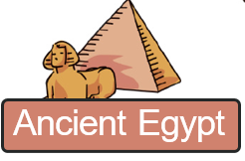
Ruby Class – The Ancient Egyptians

Choose your homework from the grid below:
You can choose as many tasks as you like. If you need a book or paper to record your work, just ask. You have the whole half term to choose and complete.
Return on Monday 19th October for marking and a reward

Try to attempt at least one task from the top line
Draw a picture of an Egyptian Pharaoh and colour.  Make it colourful and label with the words: Crown, Beard, Flail (whip) and Crook (hooked staff). | Draw a long, blue river winding down your page.  Research three things that needed water and draw these next to your river. | Make an eBook or PowerPoint presentation about Egyptian Gods using drawing, pictures and/ or photographs.
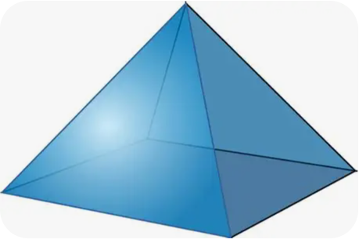  Find three things in your house that look like a triangle or a pyramid and draw them. | Use Lego, cardboard or sugar cubes to build a small pyramid model.  Bring into school or send school a photo. | Make a list of things that you would take to the afterlife using the key words below:  Afterlife, tomb, treasure, gods.
Research an Egyptian alphabet chart and draw your name inside a cartouche oval.  Ask for a chart in school if you can’t find your own in a book or online. | Write one or two sentences to describe what a Pharaoh is.  You can use the web or dictionary or text books. | Create 6 challenging quiz questions about the Ancient Egyptians.  Write the questions with correct answers.
Use the BBC Bitesize Ancient Egypt Guide to find the hieroglyphic alphabet.  https://www.bbc.co.uk/bitesize/topics/zg87xnb | Design an Egyptian Death Mask  Draw an outline of a face mask.  Colour it using bright blues, yellows and reds. You could use felt tips, crayons or even stick sequins or shiny paper if you have them at home! | 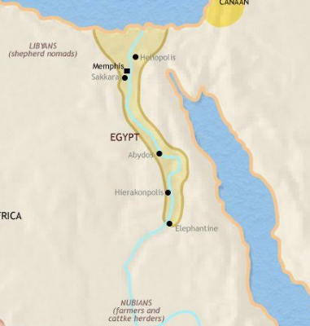  Draw a colourful map of Egypt. Be sure to mark the path of the River Nile and label nearby landmarks like the Pyramids and the Valley of the Kings.
